**PRACTICAL No.1**

**AIM: Create an Android application to demonstrate the Android Activity Lifecycle.**

**CODE:**

**activity_main.xml:**

*<?*xml version="1.0" encoding="utf-8"*?>*

<androidx.constraintlayout.widget.ConstraintLayout xmlns:android="http://schemas.android.com/apk/res/android" xmlns:app="http://schemas.android.com/apk/res-auto" xmlns:tools="http://schemas.android.com/tools" android:layout_width="match_parent"

android:layout_height="match_parent"

tools:context=".MainActivity">

<TextView

android:layout_width="wrap_content"

android:layout_height="wrap_content"

android:text="Hello Anket"

app:layout_constraintBottom_toBottomOf="parent" app:layout_constraintEnd_toEndOf="parent"

app:layout_constraintStart_toStartOf="parent" app:layout_constraintTop_toTopOf="parent" />

</androidx.constraintlayout.widget.ConstraintLayout>

**MainActivity.java :**

package com.example.applicationpractical1;

import androidx.appcompat.app.AppCompatActivity; import android.os.Bundle;

import android.util.Log;

public class MainActivity extends AppCompatActivity {

@Override

protected void onCreate(Bundle savedInstanceState) { super.onCreate(savedInstanceState);

setContentView(R.layout.*activity_main*);

Log.*d*("lifecycle","onCreate invoked");

}

@Override

protected void onStart(){

super.onStart();

Log.*d*("Lifecycle","onStart invoked"); }

@Override

protected void onResume(){

super.onResume();

Log.*d*("Lifecycle","onResume invoked"); }

@Override

protected void onPause(){

super.onPause();

Log.*d*("Lifecycle","onPause invoked"); }

@Override

protected void onStop(){

super.onStop();

Log.*d*("Lifecycle","onStop invoked"); }

@Override

protected void onRestart(){

super.onRestart();

Log.*d*("Lifecycle","onRestart invoked"); }

@Override

protected void onDestroy(){

super.onDestroy();

Log.*d*("Lifecycle","onDestroy invoked"); }

}

**OUTPUT:**

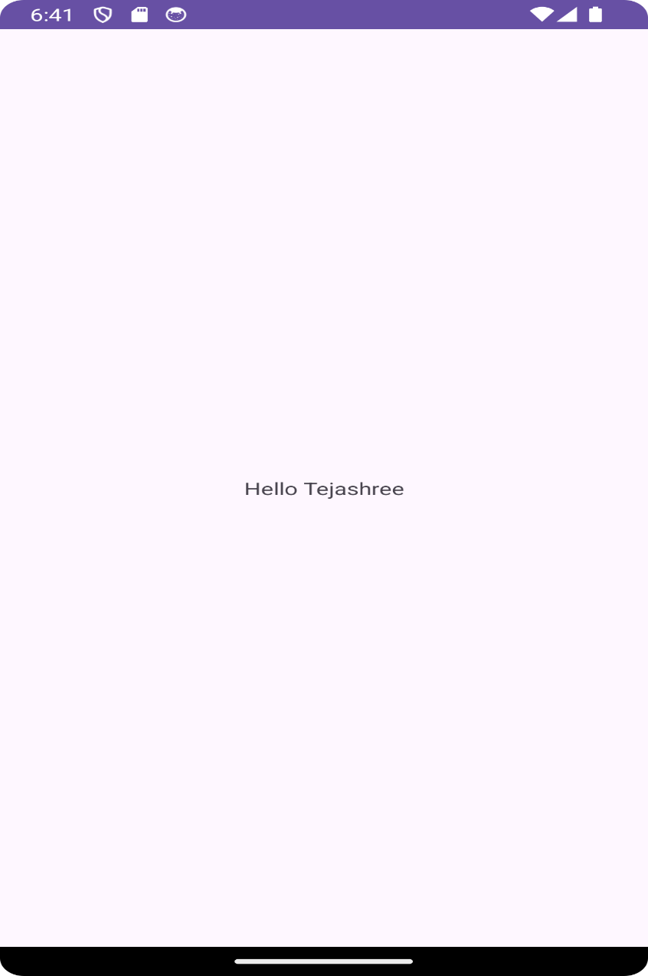

Hello Anket

**PRACTICAL No.2**

**AIM: Create Android Application to get the text from user and display it when button clicks**

**CODE:**

**activity_main.xml**

*<?*xml version="1.0" encoding="utf-8"*?>*

<androidx.constraintlayout.widget.ConstraintLayout xmlns:android="http://schemas.android.com/apk/res/android" xmlns:app="http://schemas.android.com/apk/res-auto" xmlns:tools="http://schemas.android.com/tools"

android:layout_width="match_parent"

android:layout_height="match_parent"

tools:context=".MainActivity">

<TextView

android:layout_width="wrap_content"

android:layout_height="wrap_content"

android:text="Anket"

app:layout_constraintBottom_toBottomOf="parent"

app:layout_constraintEnd_toEndOf="parent"

app:layout_constraintStart_toStartOf="parent"

app:layout_constraintTop_toTopOf="parent" />

<TextView

android:id="@+id/textView"

android:layout_width="wrap_content"

android:layout_height="wrap_content"

android:text="TextView"

tools:layout_editor_absoluteX="193dp"

tools:layout_editor_absoluteY="421dp" />

<Button

android:id="@+id/button"

android:layout_width="wrap_content"

android:layout_height="wrap_content"

android:text="Button"

tools:layout_editor_absoluteX="193dp"

tools:layout_editor_absoluteY="481dp" />

</androidx.constraintlayout.widget.ConstraintLayout>

**MainActivity.java :**

package com.example.applicationpractical2;

import androidx.appcompat.app.AppCompatActivity;

import android.annotation.SuppressLint;

import android.os.Bundle;

import android.view.View;

import android.widget.Button;

import android.widget.TextView;

public class MainActivity extends AppCompatActivity { private TextView message;

private Button button;

@SuppressLint("MissingInflatedID")

@Override

protected void onCreate(Bundle savedInstanceState) { super.onCreate(savedInstanceState);

setContentView(R.layout.*activity_main*);

button = (Button) findViewById(R.id.*button*);

message = (TextView) findViewById(R.id.*message*); message.setVisibility(View.*INVISIBLE*);

button.setOnClickListener(new View.OnClickListener(){ @Override

public void onClick(View view){

message.setVisibility(View.*VISIBLE*);

}

});

}

}

**OUTPUT:**

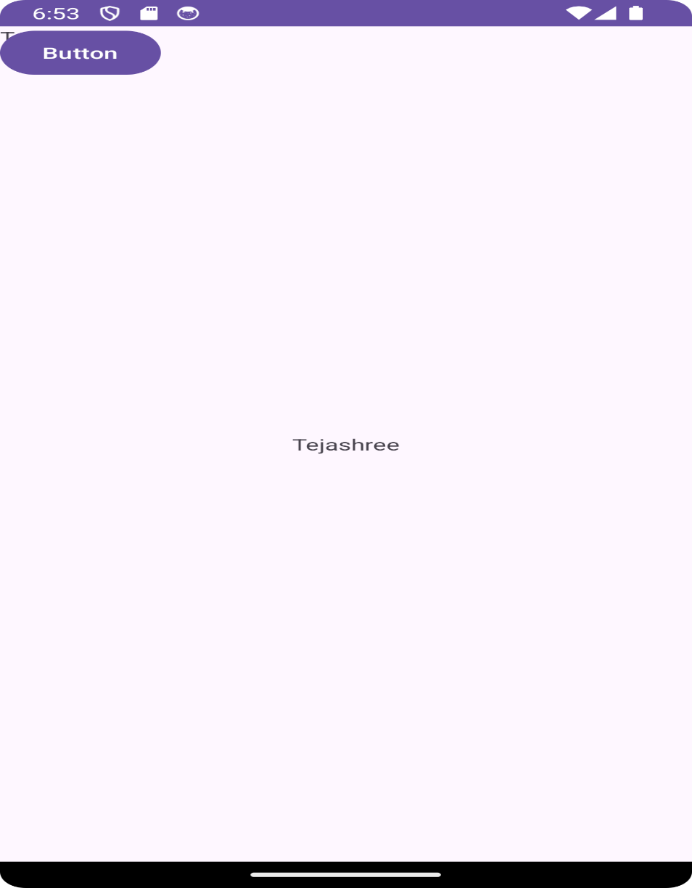

Anket

**Practical No.3**

**AIM: Create a Simple Calculator in Android Application (+,-,*,/) CODE:**

**activity_main.xml**

*<?*xml version="1.0" encoding="utf-8"*?>*

<androidx.constraintlayout.widget.ConstraintLayout xmlns:android="http://schemas.android.com/apk/res/android" xmlns:app="http://schemas.android.com/apk/res-auto" xmlns:tools="http://schemas.android.com/tools" android:layout_width="match_parent"

android:layout_height="match_parent"

tools:context=".MainActivity">

<LinearLayout

android:layout_width="match_parent"

android:layout_height="match_parent"

android:gravity="center"

android:orientation="vertical"

tools:context=".SimpleCalculator">

<EditText

android:id="@+id/num1"

android:layout_width="wrap_content"

android:layout_height="wrap_content"

android:ems="10"

android:inputType="textPersonName"

tools:hint="value 1"

tools:layout_editor_absoluteX="159dp"

tools:layout_editor_absoluteY="96dp"

/>

<EditText

android:id="@+id/num2"

android:layout_width="202dp"

android:layout_height="wrap_content"

android:inputType="textPersonName"

android:hint="Value 2"

tools:layout_editor_absoluteX="157dp"

tools:layout_editor_absoluteY="163dp" />

<Button

android:id="@+id/add"

android:layout_width="wrap_content"

android:layout_height="wrap_content"

android:text="ADD"

tools:layout_editor_absoluteX="54dp"

tools:layout_editor_absoluteY="284dp"

android:onClick="ADD"/>

<Button

android:id="@+id/sub"

android:layout_width="wrap_content"

android:layout_height="wrap_content"

android:text="SUB"

tools:layout_editor_absoluteX="203dp"

tools:layout_editor_absoluteY="278dp"

android:onClick="SUB"/>

<Button

android:id="@+id/Mul"

android:layout_width="wrap_content"

android:layout_height="wrap_content"

android:text="MUL"

tools:layout_editor_absoluteX="58dp"

tools:layout_editor_absoluteY="384dp"

android:onClick="MUL"/>

<Button

android:id="@+id/Div"

android:layout_width="wrap_content"

android:layout_height="wrap_content"

android:text="Div"

tools:layout_editor_absoluteX="209dp"

tools:layout_editor_absoluteY="377dp"

android:onClick="DIV"/>

<TextView

android:id="@+id/tv3"

android:layout_width="wrap_content"

android:layout_height="wrap_content"

android:text="Result"

tools:layout_editor_absoluteX="70dp"

tools:layout_editor_absoluteY="525dp" /> <EditText

android:id="@+id/result"

android:layout_width="wrap_content"

android:layout_height="wrap_content"

android:ems="10"

android:inputType="textPersonName"

tools:layout_editor_absoluteX="148dp"

tools:layout_editor_absoluteY="501dp" /> </LinearLayout>

</androidx.constraintlayout.widget.ConstraintLayout>

**MainActivity.java :**

package com.example.applicationpracticalcalculator; import androidx.appcompat.app.AppCompatActivity;

import android.os.Bundle;

import android.view.View;

import android.widget.Button;

import android.widget.EditText;

import android.widget.TextView;

public class MainActivity extends AppCompatActivity {

@Override

protected void onCreate(Bundle savedInstanceState) { super.onCreate(savedInstanceState);

setContentView(R.layout.*activity_main*);

}

public void ADD(View view) {

EditText num1, num2, result;

float result_num;

int x, y;

num1 = findViewById(R.id.*num1*);

num2 = findViewById(R.id.*num2*);

result = findViewById(R.id.*result*);

x = Integer.*parseInt*(num1.getText().toString()); y = Integer.*parseInt*(num2.getText().toString()); result_num = x + y;

result.setText(String.*valueOf*(result_num)); }

public void SUB(View view) {

EditText num1, num2, result;

float result_num;

int x, y;

num1 = findViewById(R.id.*num1*);

num2 = findViewById(R.id.*num2*);

result = findViewById(R.id.*result*);

x = Integer.*parseInt*(num1.getText().toString()); y =

Integer.*parseInt*(num2.getText().toString()); result_num = x - y;

result.setText(String.*valueOf*(result_num)); }

public void MUL(View view) {

EditText num1, num2, result;

float result_num;

int x, y;

num1 = findViewById(R.id.*num1*);

num2 = findViewById(R.id.*num2*);

result = findViewById(R.id.*result*);

x = Integer.*parseInt*(num1.getText().toString()); y = Integer.*parseInt*(num2.getText().toString()); result_num = x * y;

result.setText(String.*valueOf*(result_num)); }

public void DIV(View view) {

EditText num1, num2, result;

float result_num;

int x, y;

num1 = findViewById(R.id.*num1*);

num2 = findViewById(R.id.*num2*);

result = findViewById(R.id.*result*);

x = Integer.*parseInt*(num1.getText().toString()); y = Integer.*parseInt*(num2.getText().toString()); result_num = x / y;

result.setText(String.*valueOf*(result_num)); }

}

**OUTPUT:**

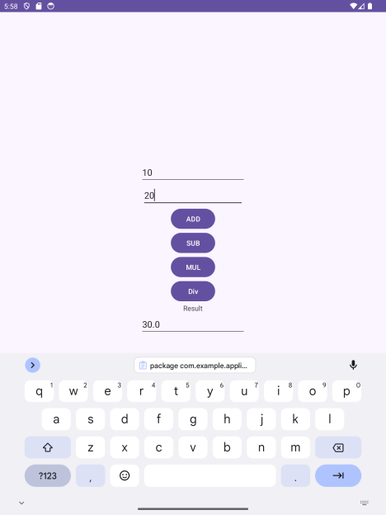

**PRACTICAL No.4**

**AIM: Create an Android application to display registration form using UI components.**

**CODE:**

**activity_main.xml**

*<?*xml version="1.0" encoding="utf-8"*?>*<androidx.constraintlayout.widget.ConstraintLayout  
 xmlns:android="http://schemas.android.com/apk/res/android"  
 xmlns:app="http://schemas.android.com/apk/res-auto"  
 xmlns:tools="http://schemas.android.com/tools"  
 android:layout_width="match_parent"  
 android:layout_height="match_parent"  
 tools:context=".MainActivity">  
 <TextView  
 android:id="@+id/tv1"  
 android:layout_width="335dp"  
 android:layout_height="78dp"  
 android:layout_alignParentStart="true"  
 android:layout_alignParentLeft="true"  
 android:layout_alignParentTop="true"  
 android:layout_alignParentEnd="true"  
 android:layout_alignParentRight="true"  
 android:layout_alignParentBottom="true"  
 android:layout_marginLeft="61dp"  
 android:layout_marginTop="29dp"  
 android:layout_marginRight="49dp"  
 android:layout_marginBottom="638dp"  
 android:text="Registration Form"  
 android:textSize="36sp"  
 app:layout_constraintBottom_toBottomOf="parent"  
 app:layout_constraintHorizontal_bias="1.0"  
 app:layout_constraintLeft_toLeftOf="parent"  
 app:layout_constraintRight_toRightOf="parent"  
 app:layout_constraintTop_toTopOf="parent"  
 app:layout_constraintVertical_bias="0.0" />  
 <TextView  
 android:id="@+id/tv_name"  
 android:layout_width="wrap_content"  
 android:layout_height="57dp"  
 android:layout_alignParentStart="true"  
 android:layout_alignParentLeft="true"  
 android:layout_alignParentTop="true"  
 android:layout_alignParentEnd="true"  
 android:layout_alignParentRight="true"  
 android:layout_alignParentBottom="true"  
 android:text="Enter Name : "  
 android:textSize="30sp"  
 app:layout_constraintBottom_toBottomOf="parent"

app:layout_constraintEnd_toEndOf="parent"  
 app:layout_constraintHorizontal_bias="0.0"  
  
 app:layout_constraintStart_toStartOf="parent"  
 app:layout_constraintTop_toTopOf="parent"  
 app:layout_constraintVertical_bias="0.286" />  
 <EditText  
 android:id="@+id/et1"  
 android:layout_width="202dp"  
 android:layout_height="wrap_content"  
 android:layout_below="@id/tv1"  
 android:layout_alignParentStart="true"  
 android:layout_alignParentLeft="true"  
 android:layout_alignParentTop="true"  
 android:layout_alignParentEnd="true"  
 android:layout_alignParentRight="true"  
 android:layout_alignParentBottom="true"  
 android:ems="10"  
 android:inputType="textPersonName"  
 android:textSize="24sp"  
 app:layout_constraintBottom_toBottomOf="parent"  
 app:layout_constraintEnd_toEndOf="parent"  
 app:layout_constraintHorizontal_bias="0.98"  
 app:layout_constraintStart_toStartOf="parent"  
 app:layout_constraintTop_toTopOf="parent"  
 app:layout_constraintVertical_bias="0.29" />  
 <RelativeLayout  
 android:id="@+id/radiogp1"  
 android:layout_width="342dp"  
 android:layout_height="86dp"  
 android:layout_alignParentStart="true"  
 android:layout_alignParentLeft="true"  
 android:layout_alignParentTop="true"  
 android:layout_alignParentEnd="true"  
 android:layout_alignParentRight="true"  
 android:layout_alignParentBottom="true"  
 app:layout_constraintBottom_toBottomOf="parent"  
 app:layout_constraintEnd_toEndOf="parent"  
 app:layout_constraintHorizontal_bias="0.768"  
 app:layout_constraintStart_toStartOf="parent"  
 app:layout_constraintTop_toTopOf="parent"  
 app:layout_constraintVertical_bias="0.471">  
 <RadioButton  
 android:id="@+id/rb1"  
 android:layout_width="149dp"  
 android:layout_height="52dp"  
 android:layout_alignParentStart="true"  
 android:layout_alignParentTop="true"  
 android:layout_alignParentEnd="true"  
 android:layout_alignParentBottom="true"  
 android:layout_marginStart="13dp"  
 android:layout_marginLeft="38dp"

android:layout_marginTop="19dp"  
 android:layout_marginEnd="180dp"  
 android:layout_marginRight="148dp"  
 android:layout_marginBottom="15dp"  
 android:text="Female"  
 android:textSize="30sp" />  
 <RadioButton  
 android:id="@+id/rb2"  
 android:layout_width="139dp"  
  
 android:layout_height="50dp"  
 android:layout_alignParentStart="true"  
 android:layout_alignParentTop="true"  
 android:layout_alignParentEnd="true"  
 android:layout_alignParentBottom="true"  
 android:layout_marginStart="188dp"  
 android:layout_marginLeft="215dp"  
 android:layout_marginTop="16dp"  
 android:layout_marginEnd="14dp"  
 android:layout_marginRight="22dp"  
 android:layout_marginBottom="20dp"  
 android:text="Male"  
 android:textSize="30sp" />  
 </RelativeLayout>  
 <CheckBox  
 android:id="@+id/cb1"  
 android:layout_width="144dp"  
 android:layout_height="wrap_content"  
 android:layout_below="@id/et1"  
 android:layout_alignParentStart="true"  
 android:layout_alignParentLeft="true"  
 android:layout_alignParentTop="true"  
 android:layout_alignParentEnd="true"  
 android:layout_alignParentRight="true"  
 android:layout_alignParentBottom="true"  
 android:layout_toRightOf="@id/cb2"  
 android:text="php"  
 android:textSize="36sp"  
 app:layout_constraintBottom_toBottomOf="parent"  
 app:layout_constraintEnd_toEndOf="parent"  
 app:layout_constraintHorizontal_bias="0.228"  
 app:layout_constraintStart_toStartOf="parent"  
 app:layout_constraintTop_toTopOf="parent"  
 app:layout_constraintVertical_bias="0.613" />  
 <CheckBox  
 android:id="@+id/cb2"  
 android:layout_width="134dp"  
 android:layout_height="52dp"  
 android:layout_alignParentStart="true"  
 android:layout_alignParentLeft="true"  
 android:layout_alignParentTop="true"  
 android:layout_alignParentEnd="true"

android:layout_alignParentRight="true"  
 android:layout_alignParentBottom="true"  
 android:text="Java"  
 android:textSize="36sp"  
 app:layout_constraintBottom_toBottomOf="parent"  
 app:layout_constraintEnd_toEndOf="parent"  
 app:layout_constraintHorizontal_bias="0.319"  
 app:layout_constraintStart_toEndOf="@+id/cb1"  
 app:layout_constraintTop_toTopOf="parent"  
 app:layout_constraintVertical_bias="0.617" />  
 <RatingBar  
 android:id="@+id/ratingbar1"  
 android:layout_width="wrap_content"  
 android:layout_height="wrap_content"  
 android:layout_alignParentStart="true"  
 android:layout_alignParentLeft="true"  
 android:layout_alignParentTop="true"  
  
 android:layout_alignParentEnd="true"  
 android:layout_alignParentRight="true"  
 android:layout_alignParentBottom="true"  
 android:layout_marginBottom="52dp"  
 app:layout_constraintBottom_toTopOf="@+id/b1"  
 app:layout_constraintEnd_toEndOf="parent"  
 app:layout_constraintHorizontal_bias="0.497"  
 app:layout_constraintStart_toStartOf="parent"  
 app:layout_constraintTop_toTopOf="parent"  
 app:layout_constraintVertical_bias="1.0" />  
 <Button  
 android:id="@+id/b1"  
 android:layout_width="150dp"  
 android:layout_height="60dp"  
 android:layout_alignParentStart="true"  
 android:layout_alignParentLeft="true"  
 android:layout_alignParentTop="true"  
 android:layout_alignParentEnd="true"  
 android:layout_alignParentRight="true"  
 android:layout_alignParentBottom="true"  
 android:text="Submit"  
 android:textSize="20sp"  
 app:layout_constraintBottom_toBottomOf="parent"  
 app:layout_constraintEnd_toEndOf="parent"  
 app:layout_constraintHorizontal_bias="0.172"  
 app:layout_constraintStart_toStartOf="parent"  
 app:layout_constraintTop_toTopOf="parent"  
 app:layout_constraintVertical_bias="0.955" />  
 <Button  
 android:id="@+id/b2"  
 android:layout_width="150dp"  
 android:layout_height="60dp"  
 android:layout_alignParentStart="true"  
 android:layout_alignParentLeft="true"  
 android:layout_alignParentTop="true"

android:layout_alignParentEnd="true"  
 android:layout_alignParentRight="true"  
 android:layout_alignParentBottom="true"  
 android:text="Google"  
 android:textSize="20sp"  
 app:layout_constraintBottom_toBottomOf="parent"  
 app:layout_constraintEnd_toEndOf="parent"  
 app:layout_constraintHorizontal_bias="0.873"  
 app:layout_constraintStart_toStartOf="parent"  
 app:layout_constraintTop_toTopOf="parent"  
 app:layout_constraintVertical_bias="0.955" />  
</androidx.constraintlayout.widget.ConstraintLayout>

**activity_main2.xml**

*<?*xml version="1.0" encoding="utf-8"*?>*<RelativeLayout xmlns:android="http://schemas.android.com/apk/res/android"  
 xmlns:app="http://schemas.android.com/apk/res-auto"  
 xmlns:tools="http://schemas.android.com/tools"  
 android:layout_width="match_parent"  
  
 android:layout_height="match_parent"  
 tools:context=".MainActivity2">  
 <TextView  
 android:id="@+id/tv1"  
 android:layout_width="wrap_content"  
 android:layout_height="96dp"  
 android:layout_alignParentStart="true"  
 android:layout_alignParentTop="true"  
 android:layout_alignParentEnd="true"  
 android:layout_alignParentRight="true"  
 android:layout_marginStart="104dp"  
 android:layout_marginTop="48dp"  
 android:layout_marginEnd="115dp"  
 android:layout_marginRight="115dp"  
 android:text="Welcome"  
 android:textSize="24sp" />  
 <TextView  
 android:id="@+id/tv_name"  
 android:layout_width="330dp"  
 android:layout_height="70dp"  
 android:layout_alignParentStart="true"  
 android:layout_alignParentLeft="true"  
 android:layout_alignParentTop="true"  
 android:layout_marginStart="37dp"  
 android:layout_marginLeft="37dp"  
 android:layout_marginTop="195dp"  
 android:layout_marginEnd="37dp"  
 android:layout_marginRight="37dp"

android:textSize="20sp" />  
 <TextView  
 android:id="@+id/tv_gender"  
 android:layout_width="334dp"

android:layout_height="78dp"  
 android:layout_alignParentStart="true"  
 android:layout_alignParentLeft="true"  
 android:layout_alignParentTop="true"  
 android:layout_marginStart="37dp"  
 android:layout_marginLeft="37dp"  
 android:layout_marginTop="300dp"  
 android:layout_marginEnd="38dp"  
 android:layout_marginRight="38dp"  
 android:layout_marginBottom="470dp"  
 android:textSize="20sp" />  
 <TextView  
 android:id="@+id/tv_Course"  
 android:layout_width="330dp"  
 android:layout_height="76dp"  
 android:layout_alignParentStart="true"  
 android:layout_alignParentLeft="true"  
 android:layout_alignParentTop="true"  
 android:layout_marginStart="38dp"  
 android:layout_marginLeft="38dp"  
 android:layout_marginTop="408dp"  
 android:layout_marginEnd="40dp"  
 android:layout_marginRight="40dp"  
 android:layout_marginBottom="414dp"  
 android:textSize="20sp" />  
  
 <TextView  
 android:id="@+id/tv_rating"  
 android:layout_width="338dp"  
 android:layout_height="75dp"  
 android:layout_alignParentStart="true"  
 android:layout_alignParentLeft="true"  
 android:layout_alignParentTop="true"  
 android:layout_marginStart="35dp"  
 android:layout_marginLeft="35dp"  
 android:layout_marginTop="508dp"  
 android:layout_marginEnd="41dp"  
 android:layout_marginRight="41dp"  
 android:layout_marginBottom="361dp"  
 android:textSize="20sp" />  
</RelativeLayout>

**MainActivity.java :**

package com.example.myapplication;  
  
import androidx.appcompat.app.AppCompatActivity;  
import android.content.Intent;  
import android.net.Uri;  
import android.os.Bundle;  
import android.view.View;  
import android.widget.Button;  
import android.widget.CheckBox;

import android.widget.EditText;  
import android.widget.RadioButton;  
import android.widget.RatingBar;  
public class MainActivity extends AppCompatActivity {  
 EditText e1;  
 RadioButton r1,r2;  
 CheckBox c1,c2;  
 Button b1, b2;  
 RatingBar rb1;  
 @Override  
 protected void onCreate(Bundle savedInstanceState) {  
 super.onCreate(savedInstanceState);  
 setContentView(R.layout.*activity_main*);  
 e1=(EditText)findViewById(R.id.*et1*);  
 r1=(RadioButton)findViewById(R.id.*rb1*);  
 r2=(RadioButton)findViewById(R.id.*rb2*);  
 c1=(CheckBox)findViewById(R.id.*cb1*);  
 c2=(CheckBox)findViewById(R.id.*cb2*);  
 rb1= (RatingBar) findViewById(R.id.*ratingbar1*);  
 b1=(Button)findViewById(R.id.*b1*);  
 b1.setOnClickListener(new View.OnClickListener() {  
 @Override  
 public void onClick(View view) {  
 String gender;  
  
 String name=e1.getText( ).toString( );  
  
 String course=" ";  
 String rating=String.*valueOf*(rb1.getRating( ));  
 if(r1.isChecked( ))  
  
 {  
 gender = r1.getText( ).toString( );  
 }  
 else  
 {  
 gender = r2.getText( ).toString( );  
 }  
 if(c1.isChecked( ))  
 {

course = c1.getText( ).toString( );  
 }  
 if(c2.isChecked( ))  
 {  
 course = course+" , "+c2.getText( ).toString( );  
 }  
  
 Intent intent=new  
  
 Intent(MainActivity.this,MainActivity.class);  
 intent.putExtra("NAME",name);  
 intent.putExtra("GENDER",gender);  
 intent.putExtra("COURSE",course);

intent.putExtra("RATING",rating);  
 startActivity(intent);  
 }  
 });  
 b2=(Button)findViewById(R.id.*b2*);  
 b2.setOnClickListener(new View.OnClickListener() {  
 @Override  
 public void onClick(View view) {  
 Intent intent = new Intent(Intent.*ACTION_VIEW*);  
 intent.setData(Uri.*parse*("https://www.google.com"));  
 startActivity(intent);  
 }  
 });  
 }  
}

**MainActivity2.java :**

package com.example.myapplication;  
  
import androidx.appcompat.app.AppCompatActivity;  
import android.content.Intent;  
import android.os.Bundle;  
import android.widget.TextView;  
public class MainActivity2 extends AppCompatActivity {  
 @Override  
 protected void onCreate(Bundle savedInstanceState) {  
 super.onCreate(savedInstanceState);  
 setContentView(R.layout.*activity_main2*);  
 TextView tv1=(TextView)findViewById(R.id.*tv_name*);  
 TextView tv2=(TextView)findViewById(R.id.*tv_gender*);  
 TextView tv3=(TextView)findViewById(R.id.*tv_Course*);  
 TextView tv4=(TextView)findViewById(R.id.*tv_rating*);  
 Intent intent=getIntent( );  
 intent.getSerializableExtra("Name");  
 String name = intent.getStringExtra("NAME");  
  
 String gender = intent.getStringExtra("GENDER");  
 String course = intent.getStringExtra("COURSE");

String rating = intent.getStringExtra("RATING");  
 tv1.setText("Name : "+name);  
 tv2.setText("Gender : "+gender);  
 tv3.setText("Course : "+course);  
 tv4.setText("Rating : "+rating);  
 }  
}

**OUTPUT:**

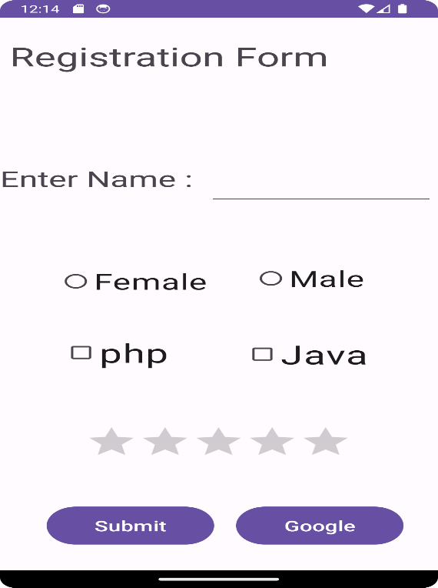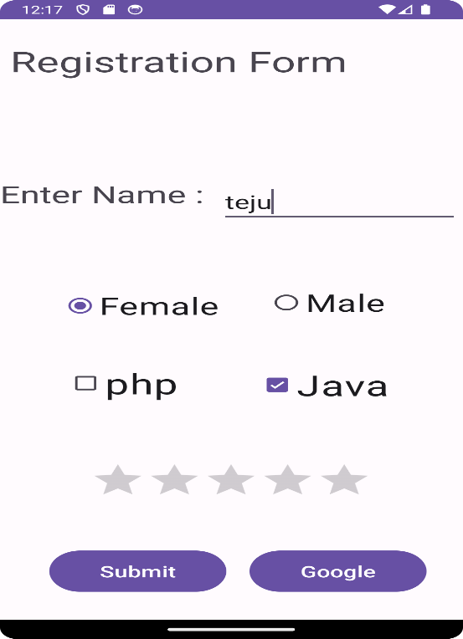

Anket

**PRACTICAL No.5**

**AIM: Create an Android application to demonstrate Toast.**

**CODE:**

**activity_main.xml**

*<?*xml version="1.0" encoding="utf-8"*?>*

<androidx.constraintlayout.widget.ConstraintLayout xmlns:android="http://schemas.android.com/apk/res/android" xmlns:app="http://schemas.android.com/apk/res-auto" xmlns:tools="http://schemas.android.com/tools" android:layout_width="match_parent"

android:layout_height="match_parent"

tools:context=".MainActivity">

<LinearLayout

android:layout_width="match_parent"

android:layout_height="match_parent"

android:orientation="vertical"

android:gravity="center"

tools:context=".MainActivity">

<Button

android:id="@+id/Div"

android:layout_width="wrap_content"

android:layout_height="wrap_content"

android:onClick="Toaster"

android:text="Toast 84"

tools:layout_editor_absoluteX="209dp"

tools:layout_editor_absoluteY="377dp" />

</LinearLayout>

</androidx.constraintlayout.widget.ConstraintLayout>

**MainActivity.java :**

package com.example.applicationpracticaltoast;

import androidx.appcompat.app.AppCompatActivity;

import android.os.Bundle;

import android.view.View;

import android.widget.Toast;

public class MainActivity extends AppCompatActivity {

@Override

protected void onCreate(Bundle savedInstanceState) { super.onCreate(savedInstanceState);

setContentView(R.layout.*activity_main*);

}

public void Toaster(View view)

{

Toast.*makeText*(this, "Welcome to Application", Toast.*LENGTH_LONG*).show();

}

}

**OUTPUT:**

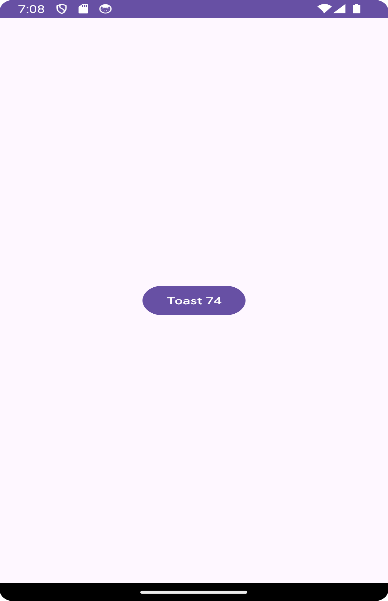

Toast 84

**PRACTICAL No.6**

**Aim : Create an Android Application to draw a filled circle using Canvas Class**

**CODE:**

**activity_main.xml**

*<?*xml version="1.0" encoding="utf-8"*?>*

<androidx.constraintlayout.widget.ConstraintLayout xmlns:android="http://schemas.android.com/apk/res/android" xmlns:app="http://schemas.android.com/apk/res-auto" xmlns:tools="http://schemas.android.com/tools" android:layout_width="match_parent"

android:layout_height="match_parent"

tools:context=".MainActivity">

<TextView

android:layout_width="wrap_content"

android:layout_height="wrap_content"

android:text="Hello World!"

app:layout_constraintBottom_toBottomOf="parent" app:layout_constraintEnd_toEndOf="parent"

app:layout_constraintStart_toStartOf="parent" app:layout_constraintTop_toTopOf="parent" />

</androidx.constraintlayout.widget.ConstraintLayout>

**MainActivity.java :**

package com.example.displaycircle;

import androidx.appcompat.app.AppCompatActivity; import android.graphics.Canvas;

import android.graphics.Color;

import android.graphics.Paint;

import android.os.Bundle;

import android.content.Context;

import android.view.View;

public class MainActivity extends AppCompatActivity {

@Override

protected void onCreate(Bundle savedInstanceState) { super.onCreate(savedInstanceState);

setContentView(new Mview(this));

}

private class Mview extends View {

public Mview(Context fileprogss) {

super(fileprogss);

}

public void onDraw(Canvas canvas)

{

super.onDraw(canvas);

int x,y;

x= getWidth();

y= getHeight();

int rad=100;

Paint p = new Paint();

p.setStyle(Paint.Style.*FILL*);

p.setColor(Color.*WHITE*);

canvas.drawPaint(p);

p.setColor(Color.*parseColor*("yellow")); canvas.drawCircle(x/2,y/2,rad,p);

canvas.drawRect(300,250,100,100,p);

}

}

}

**OUTPUT:**

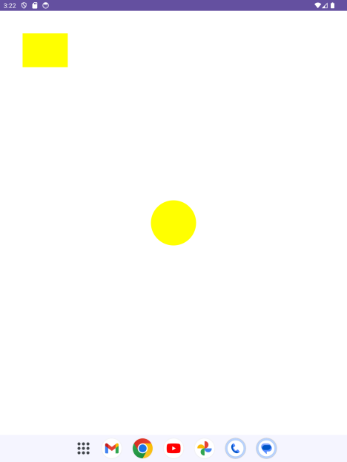

**PRACTICAL No.7**

**Aim : Create an Android application to demonstrate Alert window**

**CODE:**

**activity_main.xml**

*<?*xml version="1.0" encoding="utf-8"*?>*

<RelativeLayout xmlns:android="http://schemas.android.com/apk/res/android" xmlns:app="http://schemas.android.com/apk/res-auto"

xmlns:tools="http://schemas.android.com/tools"

android:layout_width="match_parent"

android:layout_height="match_parent"

tools:context=".MainActivity">

<TextView android:layout_width="wrap_content"

android:layout_height="wrap_content"

android:text="Anket"

app:layout_constraintBottom_toBottomOf="parent"

app:layout_constraintLeft_toLeftOf="parent"

app:layout_constraintRight_toRightOf="parent"

app:layout_constraintTop_toTopOf="parent" />

<Button android:id="@+id/Button"

android:layout_width="wrap_content"

android:layout_height="wrap_content"

android:layout_alignParentTop="true"

android:layout_centerHorizontal="true"

android:layout_marginTop="167dp"

android:text="Button"

tools:layout_editor_absoluteX="154dp"

tools:layout_editor_absoluteY="170dp" />

</RelativeLayout>

**MainActivity.java :**

package com.example.myapplication;

import androidx.appcompat.app.AlertDialog;

import androidx.appcompat.app.AppCompatActivity;

import android.os.Bundle;

import android.content.DialogInterface;

import android.widget.Button;

import android.view.View;

public class MainActivity extends AppCompatActivity {

@Override

protected void onCreate(Bundle savedInstanceState) {

super.onCreate(savedInstanceState);

setContentView(R.layout.*activity_main*);

Button button_sbm;

onButtonClickListener();

}

public void onButtonClickListener()

{

Button button_sbm = (Button) findViewById(R.id.*Button*);

button_sbm.setOnClickListener (

new View.OnClickListener()

{

@Override

public void onClick(View v)

{

AlertDialog.Builder a_builder=new

AlertDialog.Builder(MainActivity.this);

a_builder.setMessage("Do you Want to close this app")

.setCancelable(false)

.setPositiveButton("YES",new

DialogInterface.OnClickListener()

{

@Override

public void onClick(DialogInterface

dialog,int which)

{

finish();

}

})

.setNegativeButton("No",new

DialogInterface.OnClickListener()

{

public void onClick(DialogInterface

dialog,int which)

{

dialog.cancel();

}

});

AlertDialog alert=a_builder.create();

alert.setTitle("Alert!!");

alert.show();

}

}

);

}

}

**OUTPUT:**

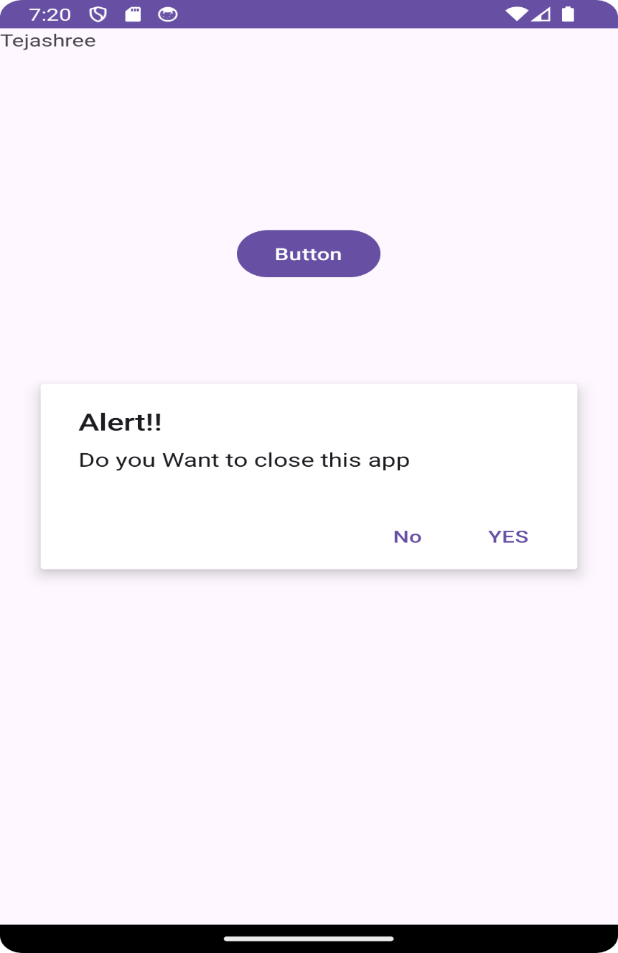

Anket

**PRACTICAL No.8**

**AIM: Create an Android Application to display image onclick of button**

**CODE:**

**activity_main.xml**

*<?*xml version="1.0" encoding="utf-8"*?>*

<RelativeLayout xmlns:android="http://schemas.android.com/apk/res/android" xmlns:app="http://schemas.android.com/apk/res-auto"

xmlns:tools="http://schemas.android.com/tools"

android:layout_width="match_parent"

android:layout_height="match_parent"

tools:context=".MainActivity">

<ImageView

android:id="@+id/iv2"

android:layout_width="match_parent"

android:layout_height="667dp"

android:layout_above="@+id/bt1"

android:layout_alignParentStart="true"

android:layout_alignParentLeft="true"

android:layout_alignParentTop="true"

android:layout_alignParentEnd="true"

android:layout_marginEnd="0dp"

android:layout_marginBottom="19dp"

android:src="@drawable/ic_launcher_foreground" />

<Button

android:id="@+id/bt1"

android:layout_width="wrap_content"

android:layout_height="wrap_content"

android:text="change"

android:layout_alignParentBottom="true"

android:layout_marginBottom="-3dp"

android:layout_centerHorizontal="true"/>

</RelativeLayout>

**MainActivity.java :**

package com.example.applicationpracticalimage;

import static com.example.applicationpracticalimage.R.drawable.*pic*;

import androidx.appcompat.app.AppCompatActivity;

import android.os.Bundle;

import android.view.View;

import android.widget.Button;

import android.widget.ImageView;

public class MainActivity extends AppCompatActivity {

@Override

protected void onCreate(Bundle savedInstanceState) { super.onCreate(savedInstanceState);

setContentView(R.layout.*activity_main*);

Button btn1 =(Button) findViewById(R.id.*bt1*); ImageView iv =(ImageView) findViewById(R.id.*iv2*); btn1.setOnClickListener(new View.OnClickListener() { @Override

public void onClick(View v) {

iv.setImageResource(*pic*);

}

});

}

}

**OUTPUT:**

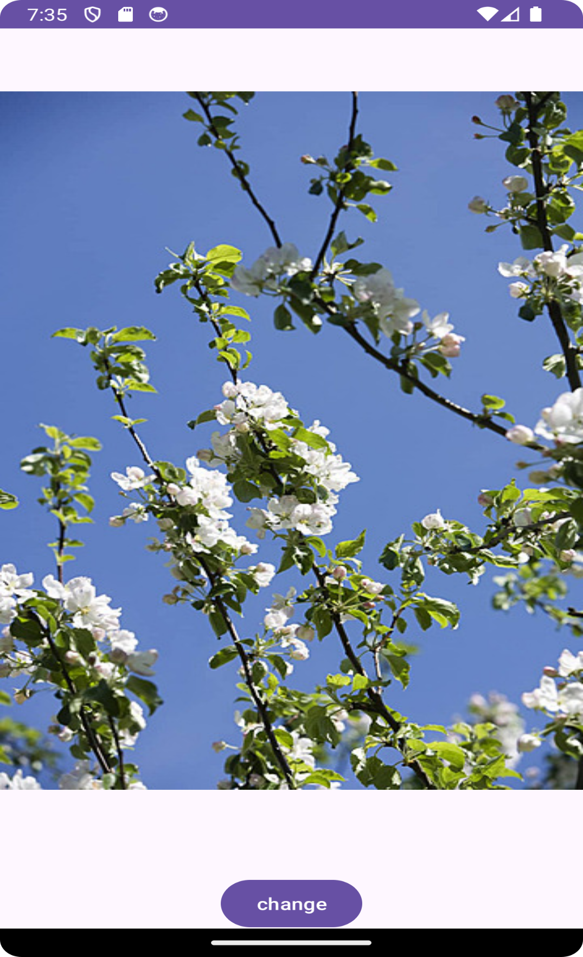

**PRACTICAL No.9**

**AIM:** **Create an Android application to display Menu (Option).**

**CODE:**

**activity_main.xml**

*<?***xml version="1.0" encoding="utf-8"***?>*

<**android.support.constraint.ConstraintLayoutxmlns:android="http://schemas.android.c om/apk/res/android"**

**xmlns:app="http://schemas.android.com/apk/res-auto"**

**xmlns:tools="http://schemas.android.com/tools"**

**android:layout_width="match_parent"**

**android:layout_height="match_parent"**

**tools:context="com.example.ashok.optionmenu.MainActivity"**>

</**android.support.constraint.ConstraintLayout**>

**menu.xml**

*<?***xml version="1.0" encoding="utf-8"***?>*

<**menu xmlns:android="http://schemas.android.com/apk/res/android"**> <**item**

**android:id="@+id/a1"**

**android:title="Add"**/>

<**item**

**android:id="@+id/a2"**

**android:title="Edit"**/>

<**item**

**android:id="@+id/a3"**

**android:title="Delete"**/>

<**item**

**android:id="@+id/a4"**

**android:title="Save"**/>

</**menu**>

**MainActivity.java**

**package** com.example.optionmenu;

**import** android.support.v7.app.AppCompatActivity;

**import** android.os.Bundle;

**import** android.view.Menu;

**import** android.view.MenuInflater;

**import** android.view.MenuItem;

**import** android.widget.Toast;

**public class** MainActivity**extends** AppCompatActivity {

@Override

**protected void** onCreate(Bundle savedInstanceState) {

**super**.onCreate(savedInstanceState);

setContentView(R.layout.***activity_main***);

}

@Override

**public boolean**onCreateOptionsMenu(Menu menu) {

MenuInflater mi=getMenuInflater();

mi.inflate(R.menu.***menu***,menu);

**return super**.onCreateOptionsMenu(menu);

 }

@Override

**public boolean**onOptionsItemSelected(MenuItem item) {

**switch**(item.getItemId())

 {

**case** R.id.***a1***:

Toast.*makeText*(MainActivity.**this**,**"add is selected"**,Toast.***LENGTH_SHORT***).show(); **break**;

**case** R.id.***a2***:

Toast.*makeText*(MainActivity.**this**,**"edit is selected"**,Toast.***LENGTH_SHORT***).show(); **break**;

**case** R.id.***a3***:

Toast.*makeText*(MainActivity.**this**,**"delete is selected"**,Toast.***LENGTH_SHORT***).show(); **break**;

**case** R.id.***a4***:

Toast.*makeText*(MainActivity.**this**,**"save is selected"**,Toast.***LENGTH_SHORT***).show(); **break**;

**default**:

Toast.*makeText*(MainActivity.**this**,**"please select**

**options"**,Toast.***LENGTH_SHORT***).show();

 }

**return super**.onOptionsItemSelected(item);

 }

}

**OUTPUT:**

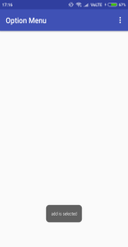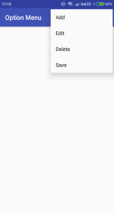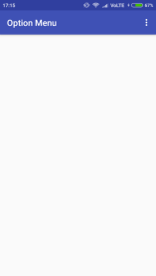

**PRACTICAL No.10**

**AIM: Create an Android application to display Video with forward, backward and pause options**

**CODE:**

**activity_main.xml**

*<?*xml version="1.0" encoding="utf-8"*?>*

<RelativeLayout xmlns:android="http://schemas.android.com/apk/res/android" xmlns:app="http://schemas.android.com/apk/res-auto"

xmlns:tools="http://schemas.android.com/tools"

android:layout_width="match_parent"

android:layout_height="match_parent"

tools:context=".MainActivity">

<VideoView

android:id="@+id/videoView1"

android:layout_width="411dp"

android:layout_height="wrap_content"

android:layout_marginStart="8dp"

android:layout_marginLeft="8dp"

android:layout_marginTop="8dp"

android:layout_marginEnd="8dp"

android:layout_marginRight="8dp"

android:layout_marginBottom="8dp"

app:layout_constraintBottom_toBottomOf="parent"

app:layout_constraintEnd_toEndOf="parent"

app:layout_constraintStart_toStartOf="parent"

app:layout_constraintTop_toTopOf="parent" />

</RelativeLayout>

**MainActivity.java :**

package com.example.practical111;

import androidx.appcompat.app.AppCompatActivity;

import android.os.Bundle;

import android.widget.MediaController;

import android.widget.VideoView;

public class MainActivity extends AppCompatActivity {

VideoView videoid;

MediaController mediaController;

@Override

protected void onCreate(Bundle savedInstanceState) {

super.onCreate(savedInstanceState);

setContentView(R.layout.*activity_main*);

videoid = (VideoView) findViewById(R.id.*videoView1*);

mediaController = new MediaController(this);

videoid.setVideoPath("android.resource://" + getPackageName() + "/" + R.raw.*video1*);

mediaController.setAnchorView(videoid);

videoid.setMediaController(mediaController);

videoid.start();

}

}

**OUTPUT:**

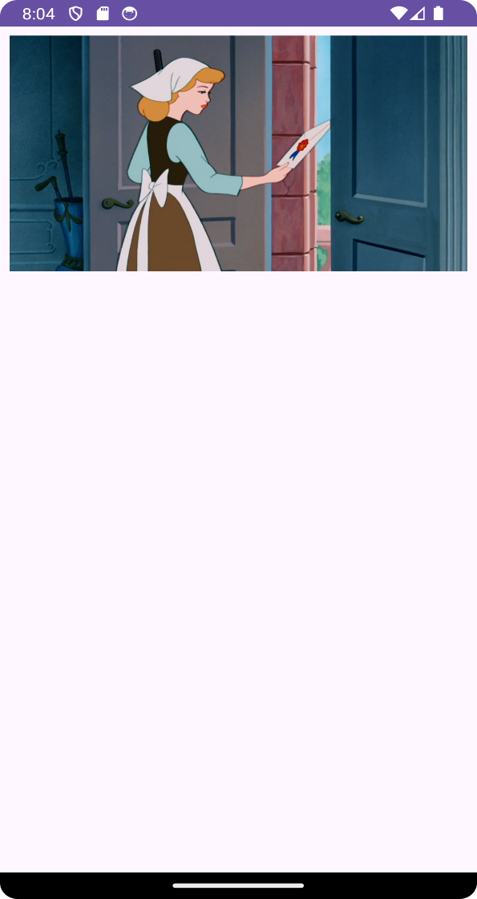

**PRACTICAL No.11**

**AIM: Create an Android Application to animate (Fade, Rotate, Move & Blink) an image.**

**CODE:**

**activity_main.xml**

*<?*xml version="1.0" encoding="utf-8"*?>*

<RelativeLayout xmlns:android="http://schemas.android.com/apk/res/android" xmlns:app="http://schemas.android.com/apk/res-auto"

xmlns:tools="http://schemas.android.com/tools"

android:layout_width="match_parent"

android:layout_height="match_parent"

tools:context=".MainActivity">

<ImageView

android:id="@+id/imageView"

android:layout_width="150dp"

android:layout_height="150dp"

android:layout_marginStart="8dp"

android:layout_marginLeft="8dp"

android:layout_marginTop="48dp"

android:layout_marginEnd="8dp"

android:layout_marginRight="8dp"

android:layout_marginBottom="8dp"

app:srcCompat="@drawable/suga" />

<Button

android:id="@+id/button"

android:layout_width="wrap_content"

android:layout_height="wrap_content"

android:layout_below="@id/button3"

android:layout_marginStart="8dp"

android:layout_marginLeft="8dp"

android:layout_marginEnd="8dp"

android:layout_marginRight="8dp"

android:onClick="move"

android:text="Move" />

<Button

android:id="@+id/button2"

android:layout_width="wrap_content"

android:layout_height="wrap_content"

android:layout_below="@id/imageView"

android:layout_centerHorizontal="true"

android:layout_marginStart="8dp"

android:layout_marginLeft="8dp"

android:layout_marginTop="8dp"

android:layout_marginEnd="8dp"

android:layout_marginRight="8dp"

android:layout_marginBottom="8dp"

android:onClick="fade"

android:text="Fade" />

<Button

android:id="@+id/button3"

android:layout_width="wrap_content"

android:layout_height="wrap_content"

android:layout_below="@id/imageView"

android:layout_marginLeft="8dp"

android:layout_marginTop="8dp"

android:layout_marginRight="8dp"

android:layout_marginBottom="8dp"

android:onClick="rotate"

android:text="Rotate" />

<Button

android:id="@+id/button4"

android:layout_width="wrap_content"

android:layout_height="wrap_content"

android:layout_below="@id/button2"

android:layout_centerHorizontal="true"

android:layout_marginBottom="8dp"

android:onClick="blink"

android:text="Blink" />

</RelativeLayout>

**MainActivity.java :**

package com.example.practical19 ;

import androidx.appcompat.app.AppCompatActivity;

import android.os.Bundle;

import android.view.View;

import android.view.animation.Animation;

import android.view.animation.AnimationUtils;

import android.widget.ImageView;

public class MainActivity extends AppCompatActivity

{

@Override

protected void onCreate(Bundle savedInstanceState)

{

super.onCreate(savedInstanceState);

setContentView(R.layout.*activity_main*);

}

public void move(View view) {

ImageView image = findViewById(R.id.*imageView*);

Animation animate1 =

AnimationUtils.*loadAnimation*(getApplicationContext(), R.anim.*move*); image.startAnimation(animate1);

}

public void fade(View view) {

ImageView image = findViewById(R.id.*imageView*);

Animation animate2 =

AnimationUtils.*loadAnimation*(getApplicationContext(), R.anim.*fade_in*); image.startAnimation(animate2);

}

public void rotate(View view) {

ImageView image = findViewById(R.id.*imageView*);

Animation animate3 =

AnimationUtils.*loadAnimation*(getApplicationContext(), R.anim.*rotate*); image.startAnimation(animate3);

}

public void blink(View view) {

ImageView image = findViewById(R.id.*imageView*);

Animation animate4 =

AnimationUtils.*loadAnimation*(getApplicationContext(), R.anim.*blink*); image.startAnimation(animate4);

}

}

**res>anim**

**blink.xml**

*<?***xml version="1.0" encoding="utf-8"***?>*

<**set xmlns:android="http://schemas.android.com/apk/res/android"**> <**alpha android:fromAlpha="0.0"**

**android:toAlpha="1.0"**

**android:interpolator="@android:anim/accelerate_interpolator" android:duration="600"**

**android:repeatMode="reverse"**

**android:repeatCount="infinite"**/>

</**set**>

**fade_in.xml**

*<?***xml version="1.0" encoding="utf-8"***?>*

<**set xmlns:android="http://schemas.android.com/apk/res/android" android:fillAfter="true"** >

<**alpha**

**android:duration="1000"**

**android:fromAlpha="0.0"**

**android:interpolator="@android:anim/accelerate_interpolator" android:toAlpha="1.0"** />

</**set**>

**move.xml**

*<?***xml version="1.0" encoding="utf-8"***?>*

<**set xmlns:android="http://schemas.android.com/apk/res/android" android:fillAfter="true"**

**android:interpolator="@android:anim/linear_interpolator"**> <**translate**

**android:duration="800"**

**android:fromXDelta="0%p"**

**android:toXDelta="75%p"** />

</**set**>

**rotate.xml**

*<?***xml version="1.0" encoding="utf-8"***?>*

<**set xmlns:android="http://schemas.android.com/apk/res/android"**> <**rotate**

**android:duration="600"**

**android:fromDegrees="0"**

**android:interpolator="@android:anim/cycle_interpolator" android:pivotX="50%"**

**android:pivotY="50%"**

**android:repeatCount="infinite"**

**android:repeatMode="restart"**

**android:toDegrees="360"** />

</**set**>

**OUTPUT:**

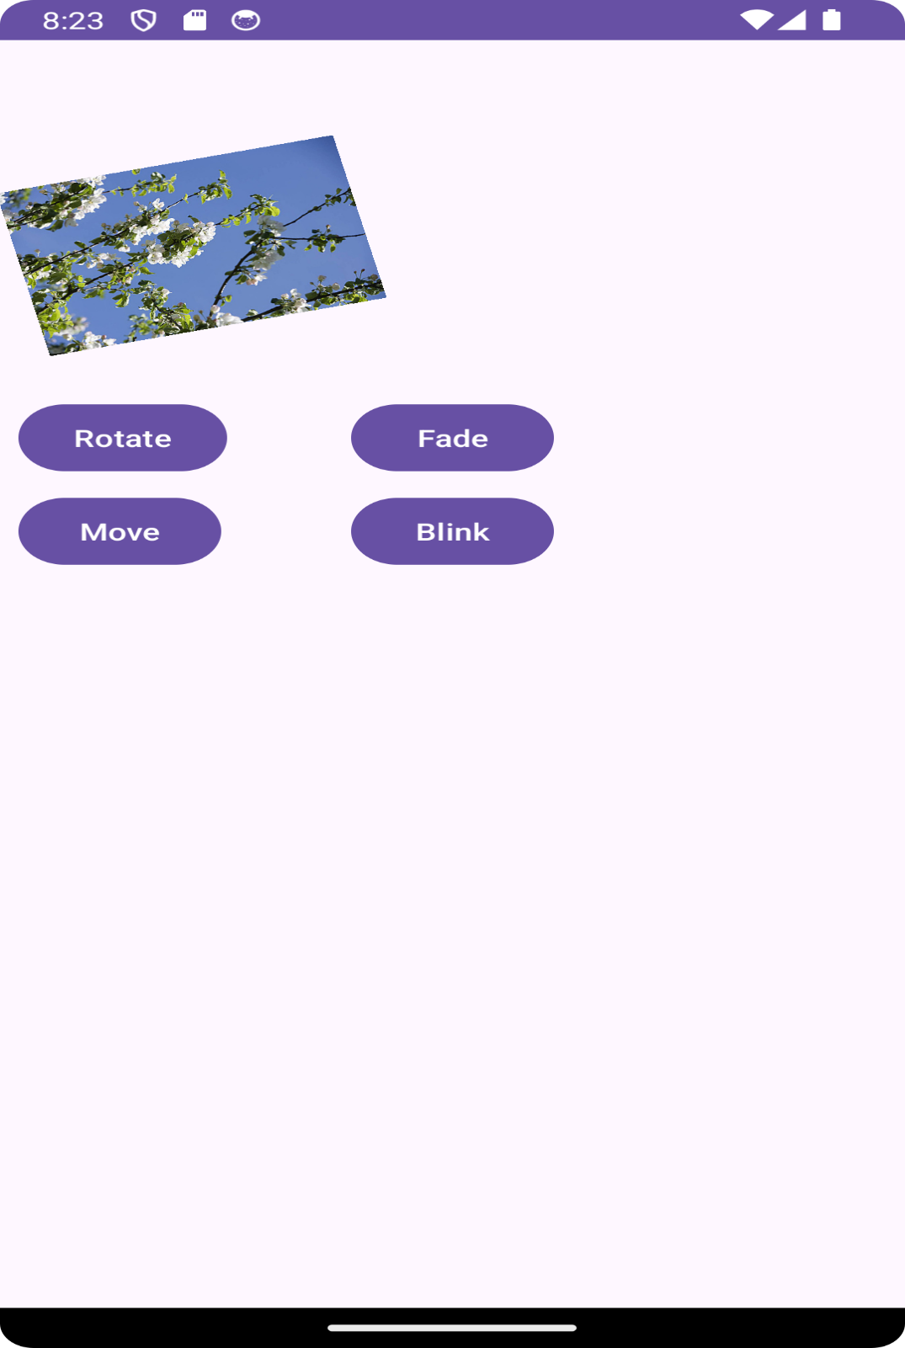

**PRACTICAL No.12**

**AIM: Create an Android application to Insert, Delete, Update and View the**

**SQLite Database**

**CODE:**

**activity_main.xml**

*<?*xml version="1.0" encoding="utf-8"*?>*

<RelativeLayout xmlns:android="http://schemas.android.com/apk/res/android" xmlns:app="http://schemas.android.com/apk/res-auto"

xmlns:tools="http://schemas.android.com/tools"

android:layout_width="match_parent"

android:layout_height="match_parent"

tools:context=".MainActivity">

<Button

android:id="@+id/btnselect"

android:layout_width="wrap_content"

android:layout_height="wrap_content"

android:layout_alignParentStart="true"

android:layout_alignParentLeft="true"

android:layout_alignParentBottom="true"

android:layout_marginStart="50dp"

android:layout_marginLeft="50dp"

android:layout_marginBottom="201dp"

android:text="View" />

<Button

android:id="@+id/btnsave"

android:layout_width="wrap_content"

android:layout_height="wrap_content"

android:layout_alignBottom="@+id/btnselect"

android:layout_alignParentEnd="true"

android:layout_alignParentRight="true"

android:layout_marginEnd="69dp"

android:layout_marginRight="69dp"

android:layout_marginBottom="0dp"

android:text="Save" />

<Button

android:id="@+id/btnupdate"

android:layout_width="wrap_content"

android:layout_height="wrap_content"

android:layout_alignStart="@+id/btnselect"

android:layout_alignLeft="@id/btnselect"

android:layout_alignParentBottom="true"

android:layout_marginStart="-7dp"

android:layout_marginLeft="-7dp"

android:layout_marginBottom="72dp"

android:text="Update" />

<Button

android:id="@+id/btnselectparticular"

android:layout_width="107dp"

android:layout_height="33dp"

android:layout_below="@+id/editTextMessage"

android:layout_alignParentStart="true"

android:layout_alignParentLeft="true"

android:layout_alignParentEnd="true"

android:layout_alignParentRight="true" android:layout_alignParentBottom="true" android:layout_marginStart="141dp" android:layout_marginLeft="141dp" android:layout_marginTop="330dp"

android:layout_marginEnd="163dp"

android:layout_marginRight="163dp" android:layout_marginBottom="127dp" android:text="Search" />

<Button

android:id="@+id/btndel"

android:layout_width="102dp"

android:layout_height="wrap_content" android:layout_below="@+id/btnsave" android:layout_alignParentStart="true" android:layout_alignParentLeft="true" android:layout_alignParentEnd="true" android:layout_alignParentRight="true" android:layout_alignParentBottom="true" android:layout_marginStart="240dp" android:layout_marginLeft="240dp" android:layout_marginTop="79dp"

android:layout_marginEnd="42dp"

android:layout_marginRight="42dp" android:layout_marginBottom="84dp"

android:text="Delete" />

<EditText

android:id="@+id/editTextSearch"

android:layout_width="wrap_content" android:layout_height="wrap_content" android:layout_alignParentStart="true" android:layout_alignParentLeft="true" android:layout_alignParentTop="true" android:layout_marginStart="79dp" android:layout_marginLeft="42dp"

android:layout_marginTop="54dp"

android:ems="10"

android:hint="Search"

android:inputType="textPersonName" android:text="" />

<EditText

android:id="@+id/editTextEmailAddress" android:layout_width="wrap_content" android:layout_height="wrap_content" android:layout_alignParentStart="true" android:layout_alignParentLeft="true" android:layout_alignParentTop="true" android:layout_marginStart="67dp" android:layout_marginLeft="67dp"

android:layout_marginTop="145dp"

android:ems="10"

android:hint="Enter Your EmailAddress" android:inputType="textPersonName" android:text="" />

<EditText

android:id="@+id/editTextMessage"

android:layout_width="wrap_content" android:layout_height="wrap_content" android:layout_alignParentStart="true" android:layout_alignParentLeft="true"

android:layout_alignParentTop="true" android:layout_marginStart="67dp"

android:layout_marginLeft="67dp"

android:layout_marginTop="196dp"

android:ems="10"

android:hint="Enter Your Message"

android:inputType="textPersonName" android:text="" />

<EditText

android:id="@+id/editTextName"

android:layout_width="wrap_content" android:layout_height="wrap_content" android:layout_alignParentStart="true" android:layout_alignParentLeft="true" android:layout_alignParentTop="true" android:layout_marginStart="69dp"

android:layout_marginLeft="69dp"

android:layout_marginTop="99dp"

android:ems="10"

android:hint="Enter Your Name"

android:inputType="textPersonName" android:text="" />

<TextView

android:id="@+id/textView5"

android:layout_width="wrap_content"

android:layout_height="wrap_content" android:layout_alignParentStart="true" android:layout_alignParentLeft="true" android:layout_alignParentTop="true" android:layout_marginStart="122dp" android:layout_marginLeft="122dp"

android:layout_marginTop="24dp"

android:text="Contact Us"

android:textSize="18sp"

android:textStyle="bold"

app:fontFamily="serif" />

</RelativeLayout>

**MainActivity.java :**

package com.example.myapplication13;

import androidx.appcompat.app.AppCompatActivity;

import android.content.Context;

import android.database.Cursor;

import android.database.sqlite.SQLiteDatabase;

import android.os.Bundle;

import android.view.View;

import android.widget.Button;

import android.widget.EditText;

import android.widget.Toast;

public class MainActivity extends AppCompatActivity implements

View.OnClickListener {

SQLiteDatabase db;

EditText editSearchContact, editName, editEmailAddress, editMessage; Button Add, Delete, Modify, View, search;

@Override

protected void onCreate(Bundle savedInstanceState) {

super.onCreate(savedInstanceState);

setContentView(R.layout.*activity_main*);

db = openOrCreateDatabase("ContactDb", Context.*MODE_PRIVATE*, null); db.execSQL("CREATE TABLE IF NOT EXISTS Contact_49(cId INTEGER PRIMARY KEY AUTOINCREMENT, Name VARCHAR, Mail VARCHAR, CMessage VARCHAR); "); editSearchContact = (EditText) findViewById(R.id.*editTextSearch*); editName = (EditText) findViewById(R.id.*editTextName*);

editEmailAddress = (EditText) findViewById(R.id.*editTextEmailAddress*); editMessage = (EditText) findViewById(R.id.*editTextMessage*); Add = (Button) findViewById(R.id.*btnsave*);

Delete = (Button) findViewById(R.id.*btndel*);

Modify = (Button) findViewById(R.id.*btnupdate*);

View = (Button) findViewById(R.id.*btnselect*);

search = (Button) findViewById(R.id.*btnselectparticular*);

Add.setOnClickListener(this);

Delete.setOnClickListener(this);

Modify.setOnClickListener(this);

View.setOnClickListener(this);

search.setOnClickListener(this);

}

public void msg(Context context, String str) {

Toast.*makeText*(this, str, Toast.*LENGTH_SHORT*).show();

}

public void onClick(android.view.View v) {

if (v.getId() == R.id.*btnsave*) {

*// code for save data*

if (editName.getText().toString().trim().length() == 0 ||

editEmailAddress.getText().toString().trim().length() == 0

||

editMessage.getText().toString().trim().length() == 0)

{

msg(this, "Please enter all values");

return;

}

db.execSQL("INSERT INTO Contact_49(Name,Mail,CMessage)VALUES('" + editName.getText() + "','" + editEmailAddress.getText() +

"','" +

editMessage.getText() + "');");

editName.getText().clear();

editEmailAddress.getText().clear();

editMessage.getText().clear();

msg(this, "Response Noted, Thanks!!");

}

else if (v.getId() == R.id.*btnupdate*)

{

*//code for update data*

if (editSearchContact.getText().toString().trim().length() == 0) { msg(this, "Enter Name");

return;

}

Cursor c = db.rawQuery("SELECT * FROM Contact_49 WHERE Name='" +

editSearchContact.getText() + "'", null);

if (c.moveToFirst()) {

db.execSQL("UPDATE Contact_49 SET Name ='" + editName.getText() + "', Mail = '" + editEmailAddress.getText() + "', CMessage = '" + editMessage.getText() + "' WHERE Name = '" +

editSearchContact.getText() +

"'");

editName.getText().clear();

editEmailAddress.getText().clear();

editMessage.getText().clear();

editSearchContact.getText().clear();

msg(this, "Record Modified");

} else {

msg(this, "Invalid Name");

}

}

else if (v.getId() == R.id.*btndel*) {

*//code for delete data*

if (editSearchContact.getText().toString().trim().length() == 0) { msg(this, " Please enter Name ");

return;

}

Cursor c = db.rawQuery("SELECT * FROM Contact_49 WHERE Name ='" +

editSearchContact.getText() + "'", null);

if (c.moveToFirst()) {

db.execSQL("DELETE FROM Contact_49 WHERE Name ='" +

editSearchContact.getText() + "'");

editName.getText().clear();

editEmailAddress.getText().clear();

editMessage.getText().clear();

msg(this, "Record Deleted");

} else {

msg(this, "Invalid Name ");

}

}

else if (v.getId() == R.id.*btnselect*) {

*//code for select all data*

Cursor c = db.rawQuery("SELECT * FROM Contact_49", null);

if (c.getCount() == 0) {

msg(this, "No records found");

return;

}

StringBuffer buffer = new StringBuffer();

while (c.moveToNext()) {

buffer.append("Name: " + c.getString(1) + "\n");

buffer.append("Mail: " + c.getString(2) + "\n\n");

buffer.append("Message: " + c.getString(3) + "\n\n");

}

msg(this, buffer.toString());

} else if (v.getId() == R.id.*btnselectparticular*) {

*//code for select particular data*

if (editSearchContact.getText().toString().trim().length() == 0) { msg(this, "Enter Name");

return;

}

Cursor c = db.rawQuery("SELECT * FROM Contact_49 WHERE Name='" +

editSearchContact.getText() + "'", null);

if (c.moveToFirst()) {

editName.setText(c.getString(1));

editEmailAddress.setText(c.getString(2));

editMessage.setText(c.getString(3));

} else {

msg(this, "Invalid Name");

}

}

}

}

**OUTPUT:**

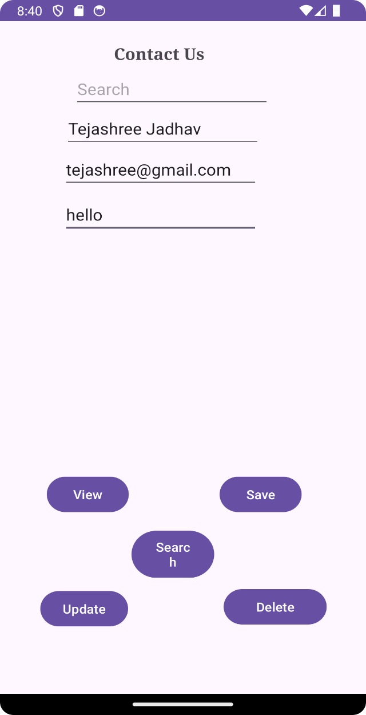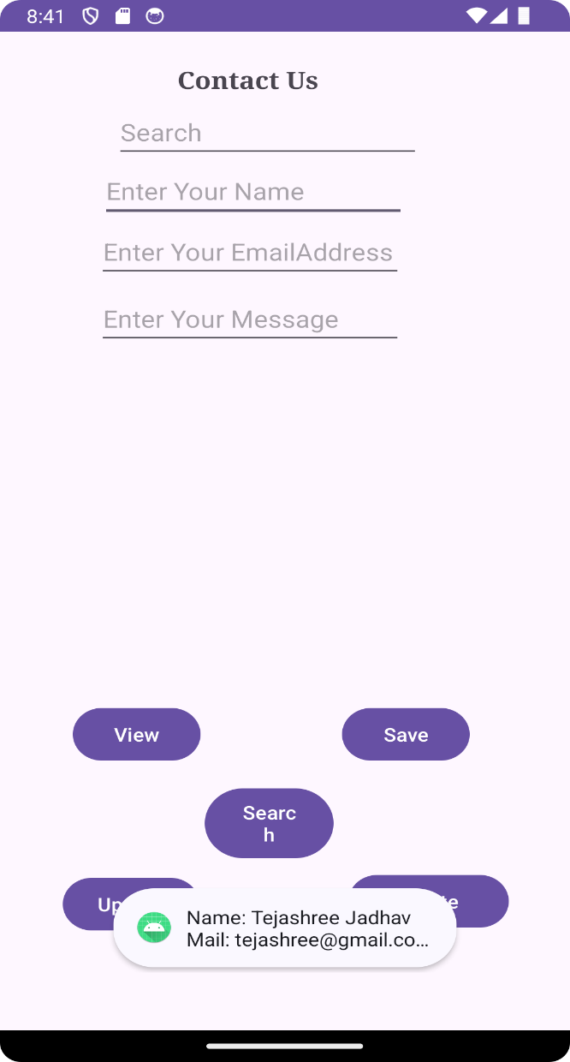

Anket Kohak

[Anketkohak40@gmail.com](mailto:Anketkohak40@gmail.com)

Hi

**PRACTICAL No.13**

**AIM: Create an Android Application to show the data of one page to the other**

**using shared preference**

**CODE:**

**activity_main.xml**

*<?*xml version="1.0" encoding="utf-8"*?>*

<androidx.constraintlayout.widget.ConstraintLayout xmlns:android="http://schemas.android.com/apk/res/android" xmlns:app="http://schemas.android.com/apk/res-auto" xmlns:tools="http://schemas.android.com/tools" android:layout_width="match_parent"

android:layout_height="match_parent"

tools:context=".MainActivity">

<TextView

android:id="@+id/textView_emailId"

android:layout_width="wrap_content"

android:layout_height="wrap_content"

android:text="Email Id :"

android:textSize="24sp"

app:layout_constraintBottom_toBottomOf="parent" app:layout_constraintEnd_toEndOf="parent"

app:layout_constraintHorizontal_bias="0.105"

app:layout_constraintStart_toStartOf="parent"

app:layout_constraintTop_toTopOf="parent"

app:layout_constraintVertical_bias="0.068" />

<TextView

android:id="@+id/textView_password"

android:layout_width="wrap_content"

android:layout_height="wrap_content"

android:text="Password :"

android:textSize="24sp"

app:layout_constraintBottom_toBottomOf="parent" app:layout_constraintEnd_toEndOf="parent"

app:layout_constraintHorizontal_bias="0.112"

app:layout_constraintStart_toStartOf="parent"

app:layout_constraintTop_toTopOf="parent"

app:layout_constraintVertical_bias="0.191" />

<TextView

android:id="@+id/textView_mobileNo"

android:layout_width="wrap_content"

android:layout_height="wrap_content"

android:text="Mobile :"

android:textSize="24sp"

app:layout_constraintBottom_toBottomOf="parent" app:layout_constraintEnd_toEndOf="parent"

app:layout_constraintHorizontal_bias="0.19"

app:layout_constraintStart_toStartOf="parent"

app:layout_constraintTop_toTopOf="parent"

app:layout_constraintVertical_bias="0.33" />

<EditText

android:id="@+id/editText_email"

android:layout_width="202dp"

android:layout_height="54dp"

android:ems="10"

android:inputType="textPersonName"

android:textSize="24sp"

app:layout_constraintBottom_toBottomOf="parent" app:layout_constraintEnd_toEndOf="parent" app:layout_constraintHorizontal_bias="0.976" app:layout_constraintStart_toStartOf="parent" app:layout_constraintTop_toTopOf="parent" app:layout_constraintVertical_bias="0.07" />

<EditText

android:id="@+id/editText_password"

android:layout_width="191dp"

android:layout_height="43dp"

android:ems="10"

android:inputType="textPersonName"

android:textSize="24sp"

app:layout_constraintBottom_toBottomOf="parent" app:layout_constraintEnd_toEndOf="parent" app:layout_constraintHorizontal_bias="0.981" app:layout_constraintStart_toStartOf="parent" app:layout_constraintTop_toTopOf="parent" app:layout_constraintVertical_bias="0.193" />

<EditText

android:id="@+id/editText_mobile"

android:layout_width="202dp"

android:layout_height="54dp"

android:ems="10"

android:inputType="phone"

android:textSize="24sp"

app:layout_constraintBottom_toBottomOf="parent" app:layout_constraintEnd_toEndOf="parent" app:layout_constraintHorizontal_bias="0.866"

app:layout_constraintStart_toStartOf="parent" app:layout_constraintTop_toTopOf="parent" app:layout_constraintVertical_bias="0.33" />

<CheckBox

android:id="@+id/checkBox"

android:layout_width="wrap_content"

android:layout_height="wrap_content"

android:text="Remember Me"

android:textSize="18sp"

app:layout_constraintBottom_toBottomOf="parent" app:layout_constraintEnd_toEndOf="parent"

app:layout_constraintStart_toStartOf="parent" app:layout_constraintTop_toTopOf="parent" /> <Button

android:id="@+id/button_signIn"

android:layout_width="wrap_content"

android:layout_height="wrap_content"

android:onClick="Save"

android:text="Sign In"

android:textSize="18sp"

app:layout_constraintBottom_toBottomOf="parent" app:layout_constraintEnd_toEndOf="parent" app:layout_constraintHorizontal_bias="0.216" app:layout_constraintStart_toStartOf="parent" app:layout_constraintTop_toTopOf="parent" app:layout_constraintVertical_bias="0.639" /> <Button

android:id="@+id/button_clear"

android:layout_width="wrap_content"

android:layout_height="wrap_content"

android:onClick="clear"

android:text="Clear"

android:textSize="18sp"

app:layout_constraintBottom_toBottomOf="parent" app:layout_constraintEnd_toEndOf="parent" app:layout_constraintHorizontal_bias="0.526" app:layout_constraintStart_toStartOf="parent" app:layout_constraintTop_toTopOf="parent" app:layout_constraintVertical_bias="0.758" /> <Button

android:id="@+id/button_getData"

android:layout_width="wrap_content"

android:layout_height="wrap_content"

android:onClick="Get"

android:text="Get Data"

android:textSize="18sp"

app:layout_constraintBottom_toBottomOf="parent" app:layout_constraintEnd_toEndOf="parent" app:layout_constraintHorizontal_bias="0.848" app:layout_constraintStart_toStartOf="parent" app:layout_constraintTop_toTopOf="parent" app:layout_constraintVertical_bias="0.639" /> </androidx.constraintlayout.widget.ConstraintLayout>

**MainActivity.java :**

package com.example.practical14;

import androidx.appcompat.app.AppCompatActivity; import android.content.Context;

import android.content.SharedPreferences;

import android.os.Bundle;

import android.view.View;

import android.widget.CheckBox;

import android.widget.TextView;

import android.widget.Toast;

public class MainActivity extends AppCompatActivity {

SharedPreferences sharedPreferences;

TextView password;

TextView email;

TextView mobile;

CheckBox remember;

public static final String *mypreferences* = "mypref";

public static final String *Email* = "emailKey";

public static final String *Password* = "passwordKey";

public static final String *Mobile* = "mobileKey";

@Override

protected void onCreate(Bundle savedInstanceState) {

super.onCreate(savedInstanceState);

setContentView(R.layout.*activity_main*);

email = (TextView) findViewById(R.id.*editText_email*);

password = (TextView) findViewById(R.id.*editText_password*); mobile = (TextView) findViewById(R.id.*editText_mobile*); remember = (CheckBox) findViewById(R.id.*checkBox*);

sharedPreferences = getSharedPreferences(*mypreferences*, Context.*MODE_PRIVATE*);

if (sharedPreferences.contains(*Email*)) {

email.setText(sharedPreferences.getString(*Email*, ""));

}

if (sharedPreferences.contains(*Password*)) {

password.setText(sharedPreferences.getString(*Password*, " ")); }

if (sharedPreferences.contains(*Mobile*)) {

mobile.setText(sharedPreferences.getString(*Mobile*, " ")); }

}

public void Get(View view) {

email = (TextView) findViewById(R.id.*editText_email*);

password = (TextView) findViewById(R.id.*editText_password*); mobile = (TextView) findViewById(R.id.*editText_mobile*); sharedPreferences = getSharedPreferences(*mypreferences*, Context.*MODE_PRIVATE*);

if (sharedPreferences.contains(*Email*)) {

email.setText(sharedPreferences.getString(*Email*, " ")); }

if (sharedPreferences.contains(*Password*)) {

password.setText(sharedPreferences.getString(*Password*, " ")); }

if (sharedPreferences.contains(*Mobile*)) {

mobile.setText(sharedPreferences.getString(*Mobile*, " "));

}

}

public void Save(View view) {

if (remember.isChecked()) {

String e = email.getText().toString();

String p = password.getText().toString();

String m = mobile.getText().toString();

SharedPreferences.Editor editor = sharedPreferences.edit(); editor.putString(*Email*, e);

editor.putString(*Password*, p);

editor.putString(*Mobile*, m);

editor.commit();

Toast toast = Toast.*makeText*(getApplicationContext(), "Value stored in shared preference",

Toast.*LENGTH_SHORT*);

toast.show();

}

}

public void clear(View view) {

email = (TextView) findViewById(R.id.*editText_email*);

password = (TextView) findViewById(R.id.*editText_password*); mobile = (TextView) findViewById(R.id.*editText_mobile*);

email.setText(" ");

password.setText(" ");

mobile.setText(" ");

}

}

**OUTPUT:**

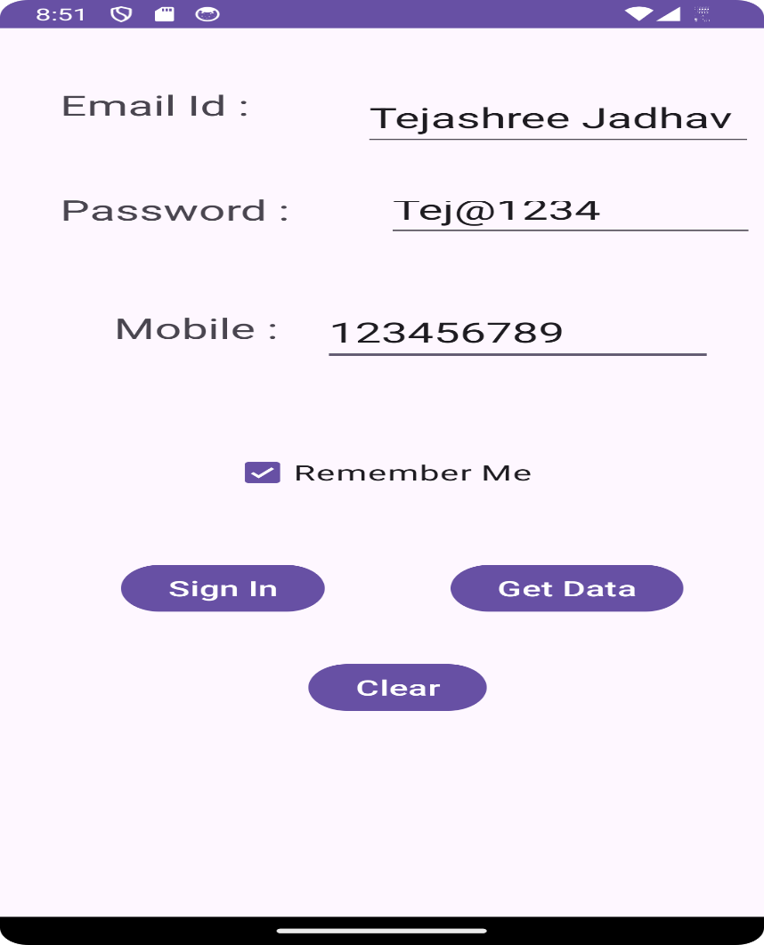

[Anketkohak40@gmail.com](mailto:Anketkohak40@gmail.com)

Anket

93252490391

**PRACTICAL No.14**

**AIM: Create an Android Application to Create, Read and Delete file (Internal)**

**CODE:**

**activity_main.xml**

*<?*xml version="1.0" encoding="utf-8"*?>*

<RelativeLayout xmlns:android="http://schemas.android.com/apk/res/android" xmlns:app="http://schemas.android.com/apk/res-auto"

xmlns:tools="http://schemas.android.com/tools"

android:layout_width="match_parent"

android:layout_height="match_parent"

tools:context=".MainActivity">

<EditText

android:id="@+id/txtcontent"

android:layout_width="246dp"

android:layout_height="wrap_content"

android:layout_alignParentTop="true"

android:layout_alignParentEnd="true"

android:layout_alignParentRight="true"

android:layout_marginTop="59dp"

android:layout_marginEnd="162dp"

android:layout_marginRight="162dp"

android:ems="10"

android:inputType="textPersonName" />

<Button

android:id="@+id/btnwrite"

android:layout_width="103dp"

android:layout_height="wrap_content"

android:layout_alignStart="@+id/txtcontent"

android:layout_alignLeft="@+id/txtcontent"

android:layout_alignTop="@+id/btnread"

android:layout_marginStart="277dp"

android:layout_marginLeft="277dp"

android:layout_marginTop="1dp"

android:text="Write" />

<Button

android:id="@+id/btnread"

android:layout_width="100dp"

android:layout_height="wrap_content"

android:layout_alignParentTop="true"

android:layout_marginTop="153dp"

android:text="Read" />

<TextView

android:id="@+id/textView"

android:layout_width="259dp"

android:layout_height="55dp"

android:layout_alignParentStart="true"

android:layout_alignParentLeft="true"

android:layout_alignParentBottom="true"

android:layout_marginStart="94dp"

android:layout_marginLeft="94dp"

android:layout_marginBottom="420dp"

android:text="TextView" />

<Button

android:id="@+id/btn_clear"

android:layout_width="110dp"

android:layout_height="34dp"

android:layout_alignTop="@+id/btnwrite" android:layout_alignParentEnd="true" android:layout_alignParentRight="true" android:layout_marginStart="41dp"

android:layout_marginLeft="41dp"

android:layout_marginTop="1dp"

android:layout_marginEnd="160dp"

android:layout_marginRight="160dp"

android:layout_toEndOf="@+id/btnread" android:layout_toRightOf="@+id/btnread" android:onClick="clearFile"

android:text="Clear" />

<Button

android:id="@+id/btn_delete"

android:layout_width="126dp"

android:layout_height="33dp"

android:layout_alignTop="@+id/btn_clear"

android:layout_alignParentEnd="true" android:layout_alignParentRight="true" android:layout_marginTop="44dp"

android:layout_marginEnd="146dp"

android:layout_marginRight="146dp"

android:onClick="deleteFile"

android:text="Delete" />

</RelativeLayout>

**MainActivity.java :**

package com.example.practical15;

import androidx.appcompat.app.AppCompatActivity; import android.os.Bundle;

import android.content.Context;

import android.view.View;

import android.widget.EditText;

import android.widget.TextView;

import android.widget.Button;

import android.widget.Toast;

import java.io.File;

import java.io.FileInputStream;

import java.io.FileOutputStream;

public class MainActivity extends AppCompatActivity {

EditText et_Text;

Button b_read, b_write, b_delete;

TextView tv_Text;

String file_name = "file.txt";

@Override

protected void onCreate(Bundle savedInstanceState) {

super.onCreate(savedInstanceState);

setContentView(R.layout.*activity_main*);

et_Text = (EditText) findViewById(R.id.*txtcontent*);

b_read = (Button) findViewById(R.id.*btnread*);

b_write = (Button) findViewById(R.id.*btnwrite*);

tv_Text = (TextView) findViewById(R.id.*textView*);

b_delete = (Button) findViewById(R.id.*btn_delete*);

b_read.setOnClickListener(new View.OnClickListener() {

@Override

public void onClick(View view) {

tv_Text.setText(readFile(file_name));

}

});

b_write.setOnClickListener(new View.OnClickListener() {

@Override

public void onClick(View view) {

saveFile(file_name, et_Text.getText().toString());

Toast.*makeText*(MainActivity.this, "saved text", Toast.*LENGTH_SHORT*).show(); }

});

}

public void saveFile(String file_name, String text) {

try {

FileOutputStream fos = openFileOutput(file_name,

Context.*MODE_PRIVATE*);

fos.write(text.getBytes());

fos.close();

Toast.*makeText*(MainActivity.this, "", Toast.*LENGTH_SHORT*).show(); } catch (Exception e) {

e.printStackTrace();

Toast.*makeText*(MainActivity.this, "Error saving

file",Toast.*LENGTH_SHORT*).show();

}

}

public String readFile(String file_name) {

String text = "";

try {

FileInputStream fis = openFileInput(file_name); int size =

fis.available();

byte[] buffer = new byte[size];

fis.read(buffer);

fis.close();

text = new String(buffer);

} catch (Exception e) {

e.printStackTrace();

Toast.*makeText*(MainActivity.this, "Error Read file", Toast.*LENGTH_SHORT*).show();

}

return text;

}

public void clearFile(View view) {

et_Text.getText().clear();

}

public void deleteFile(View view) {

File file = new File(getFilesDir(), file_name);

if (file.exists()) {

file.delete();

*// deleteFile(filename);*

Toast.*makeText*(MainActivity.this, "file Deleted", Toast.*LENGTH_SHORT*).show(); } else {

Toast.*makeText*(MainActivity.this, "file not found", Toast.*LENGTH_SHORT*).show();

}

}

}

**OUTPUT:**

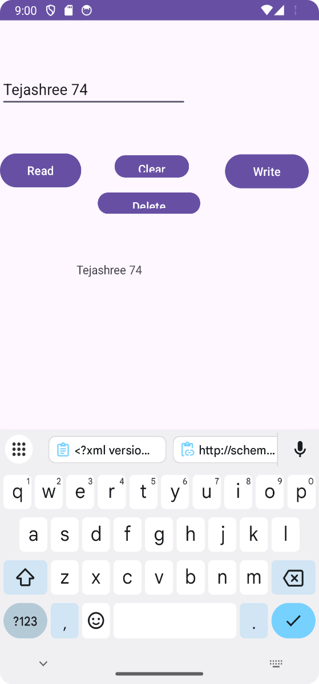

Anket 84

**PRACTICAL No.15**

**AIM: Create an Android Application to Start and Stop Alarm using Services**

**CODE:**

**activity_main.xml**

<?xml version="1.0" encoding="utf-8"?>  
<LinearLayout  
 xmlns:android="http://schemas.android.com/apk/res/android"  
 xmlns:app="http://schemas.android.com/apk/res-auto"  
 xmlns:tools="http://schemas.android.com/tools"  
 android:layout_width="match_parent"  
 android:layout_height="match_parent"  
 android:orientation="vertical"  
 tools:context=".MainActivity">  
 <TextView  
 android:layout_width="wrap_content"  
 android:layout_height="wrap_content"  
 android:text="Start Stop"  
 app:layout_constraintBottom_toBottomOf="parent"  
 app:layout_constraintLeft_toLeftOf="parent"  
 app:layout_constraintRight_toRightOf="parent"  
 app:layout_constraintTop_toTopOf="parent" />  
 <Button  
 android:layout_width="wrap_content"  
 android:layout_height="wrap_content"  
 android:onClick="onClick"  
 android:id="@+id/start"  
 android:text="Start"/>  
 <Button  
 android:layout_width="wrap_content"  
 android:layout_height="wrap_content"  
 android:onClick="onClick"  
 android:text="Stop"  
 android:id="@+id/stop"/>  
</LinearLayout>

**MainActivity.java :**

package com.example.myapplication2;  
  
import androidx.appcompat.app.AppCompatActivity ;  
import android.content.Intent;  
import android.media.MediaPlayer;  
import android.os.Bundle;  
import android.provider.Settings;  
import android.sax.StartElementListener;  
import android.view.View;  
import android.widget.Button;  
public class MainActivity extends AppCompatActivity implements

View.OnClickListener{  
 private Button b1,b2;  
 @Override  
 protected void onCreate(Bundle savedInstanceState) {  
 super.onCreate(savedInstanceState);  
 setContentView(R.layout.*activity_main*);  
 b1=(Button)findViewById(R.id.*start*);  
 b2=(Button)findViewById(R.id.*stop*);  
 b1.setOnClickListener(this);  
 b2.setOnClickListener(this);  
 }  
 public void onClick(View view) {  
 if(view==b1)  
 {  
 startService(new Intent(this,MyService.class));  
 }  
 else  
 {  
 stopService(new Intent(this,MyService.class));  
 }  
 }  
}

**MyService.java:**

package com.example.myapplication2;  
import android.app.Service;  
import android.content.Intent;  
import android.media.MediaPlayer;  
import android.os.IBinder;  
import android.provider.Settings;  
import androidx.annotation.Nullable;  
public class MyService extends Service {  
 public MyService() {  
 super();  
 }  
 MediaPlayer m;  
 @Override  
 public int onStartCommand(Intent intent, int flags, int startId) {  
 m=MediaPlayer.create(this, Settings.System.DEFAULT_RINGTONE_URI);  
 m.setLooping(true);  
 m.start();  
 return START_STICKY;  
 }  
 @Override  
 public void onDestroy() {  
 super.onDestroy();  
 m.stop();  
 }  
 @Nullable  
 @Override  
 public IBinder onBind(Intent intent) {  
 return null;  
 }  
}

**OUTPUT:**

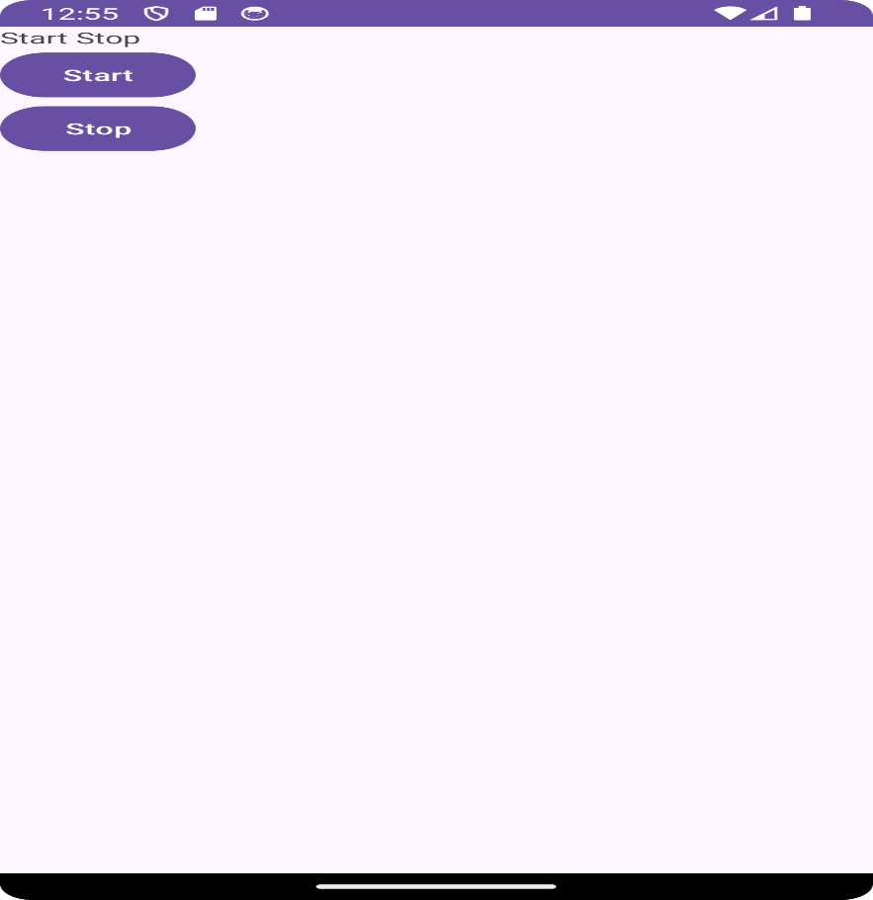

**PRACTICAL No.16**

**AIM: Create an Android Application to get latitude and longitude of current location**

**CODE:**

**activity_main.xml**

*<?*xml version="1.0" encoding="utf-8"*?>*<RelativeLayout xmlns:android="http://schemas.android.com/apk/res/android"  
 xmlns:app="http://schemas.android.com/apk/res-auto"  
 xmlns:tools="http://schemas.android.com/tools"  
 android:layout_width="match_parent"  
 android:layout_height="match_parent"  
 tools:context=".MainActivity">  
 <TextView  
 android:layout_width="match_parent"  
 android:layout_height="wrap_content"  
 android:gravity="center_horizontal"  
 android:text="SaaP Group"  
 android:textAlignment="center"  
 android:textSize="30dp" />  
 <TextView  
 android:id="@+id/location"  
 android:layout_width="338dp"  
 android:layout_height="196dp"  
 android:layout_alignParentStart="true"  
 android:layout_alignParentLeft="true"  
 android:layout_alignParentTop="true"  
 android:layout_marginStart="22dp"  
 android:layout_marginLeft="22dp"  
 android:layout_marginTop="66dp"  
 android:text="Text View" />  
 <Button  
 android:id="@+id/btn"  
 android:layout_width="156dp"  
 android:layout_height="wrap_content"  
 android:layout_alignParentStart="true"  
 android:layout_alignParentLeft="true"  
 android:layout_alignParentBottom="true"  
 android:layout_marginStart="115dp"  
 android:layout_marginLeft="115dp"  
 android:layout_marginBottom="223dp"  
 android:text="Location" />  
</RelativeLayout>

**MainActivity.java :**

package com.example.myapplication3;  
  
import android.content.pm.PackageManager;  
import android.location.Location;  
import android.os.Build;  
import android.os.Bundle;  
import android.view.View;  
import android.widget.Button;  
import android.widget.TextView;  
import androidx.annotation.RequiresApi;  
import androidx.appcompat.app.AppCompatActivity;  
import androidx.core.app.ActivityCompat;

import com.google.android.gms.location.FusedLocationProviderClient;  
import com.google.android.gms.location.LocationServices;  
import com.google.android.gms.tasks.OnSuccessListener;  
import static android.Manifest.permission.ACCESS_FINE_LOCATION;  
public class MainActivity extends AppCompatActivity {  
 private FusedLocationProviderClient c1;  
 @RequiresApi(api = Build.VERSION_CODES.M)  
 @Override  
 protected void onCreate(Bundle savedInstanceState) {  
 super.onCreate(savedInstanceState);  
 setContentView(R.layout.activity_main);  
 requestPermissions();  
 c1=LocationServices.getFusedLocationProviderClient(this);  
 Button btn1=(Button)findViewById(R.id.btn);  
 btn1.setOnClickListener(new View.OnClickListener() {  
 @Override  
 public void onClick(View view) {  
 if(ActivityCompat.checkSelfPermission(MainActivity.this,ACCESS_FINE_LOCATION)!=PackageManager.PERMISSION_GRANTED)  
 {  
 return;  
 }  
 c1.getLastLocation().addOnSuccessListener(MainActivity.this,new  
 OnSuccessListener<Location>()  
 {  
 @Override  
 public void onSuccess(Location location){  
 if(location!=null)  
 {  
  
 TextView tv=(TextView)findViewById(R.id.location);

tv.setText(location.toString());  
 }  
 }  
 });  
 }  
 });  
 }  
 private void requestPermissions() {  
 ActivityCompat.requestPermissions(this,new String[]{ACCESS_FINE_LOCATION},1);  
 }  
}

**OUTPUT:**

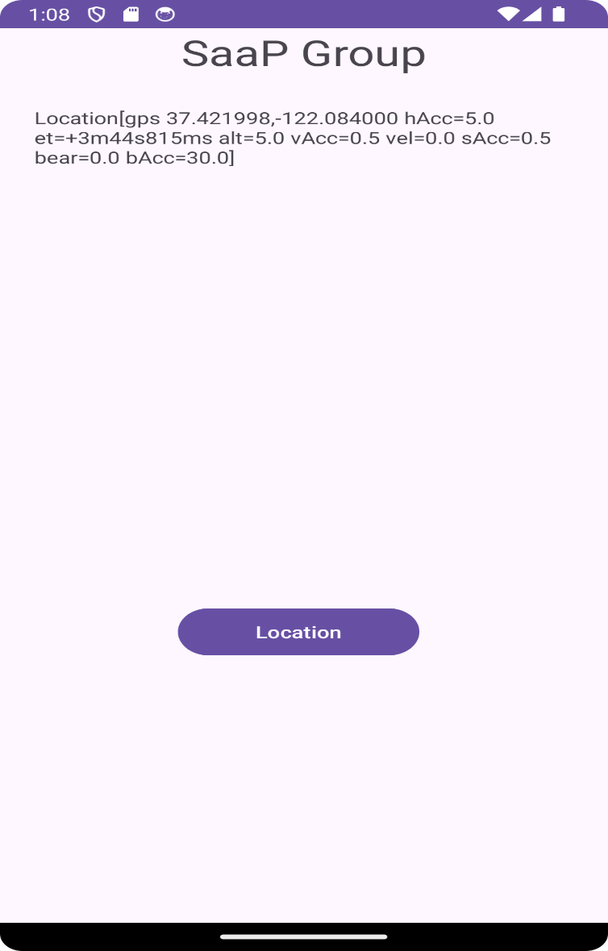

**PRACTICAL No.17**

**AIM: Create an Android application to Insert, Delete, Update and View the SQL DatabaseHelper**

**CODE:**

**activity_main.xml**

<?xml version="1.0" encoding="utf-8"?>  
<LinearLayout xmlns:android="http://schemas.android.com/apk/res/android"  
 android:layout_width="match_parent"  
 android:layout_height="match_parent"  
 android:background="#BAE4F6"  
 android:orientation="vertical">  
 <EditText  
 android:id="@+id/text1"  
 android:layout_width="100dp"  
 android:layout_height="50dp"  
 android:hint="Name"  
 android:textSize="15sp" />  
 <EditText  
 android:id="@+id/text2"  
 android:layout_width="100dp"  
 android:layout_height="50dp"  
 android:hint="Surname"  
 android:textSize="15sp" />  
 <EditText  
 android:id="@+id/text3"  
 android:layout_width="100dp"  
 android:layout_height="50dp"  
 android:hint="Marks."  
 android:textSize="15sp" />  
 <EditText  
 android:id="@+id/text4"  
 android:layout_width="100dp"  
 android:layout_height="50dp"  
 android:hint="Id"  
 android:textSize="15sp" />  
 <LinearLayout  
 android:layout_width="match_parent"  
 android:layout_height="match_parent"  
 android:background="#F67979">  
 <Button  
 android:id="@+id/button1"  
  
 android:layout_width="wrap_content"  
 android:layout_height="wrap_content"  
 android:layout_marginLeft="10dp"  
 android:layout_marginRight="5dp"  
 android:text="Add" />

<Button  
 android:id="@+id/button2"  
 android:layout_width="wrap_content"  
 android:layout_height="wrap_content"  
 android:layout_marginRight="5dp"  
 android:text="View" />  
 <Button  
 android:id="@+id/button3"  
 android:layout_width="wrap_content"  
 android:layout_height="wrap_content"

android:layout_marginRight="5dp"  
 android:text="Update" />  
 <Button  
 android:id="@+id/button4"  
 android:layout_width="wrap_content"  
 android:layout_height="wrap_content"  
 android:layout_marginRight="5dp"  
 android:text="Delete" />  
 </LinearLayout>  
</LinearLayout>

**MainActivity.java :**

package com.example.myapplication4;  
  
import androidx.appcompat.app.AlertDialog;  
import androidx.appcompat.app.AppCompatActivity;  
import android.database.Cursor;  
import android.os.Bundle;  
import android.view.View;  
import android.widget.Button;  
import android.widget.EditText;  
import android.widget.Toast;  
public class MainActivity extends AppCompatActivity {  
 DatabaseHelper myDb;  
 EditText editName, editSurname, editMarks, editTextId;  
 Button btnAddData;  
 Button btnviewAll;  
 Button btnDelete;  
 Button btnviewUpdate;  
 @Override  
 protected void onCreate(Bundle savedInstanceState) {  
 super.onCreate(savedInstanceState);  
 setContentView(R.layout.*activity_main*);  
 myDb = new DatabaseHelper(this);

editName = (EditText) findViewById(R.id.*text1*);  
  
 editSurname = (EditText) findViewById(R.id.*text2*);  
 editMarks = (EditText) findViewById(R.id.*text3*);  
 editTextId = (EditText) findViewById(R.id.*text4*);  
 btnAddData = (Button) findViewById(R.id.*button1*);  
 btnviewAll = (Button) findViewById(R.id.*button2*);  
 btnviewUpdate = (Button) findViewById(R.id.*button3*);  
 btnDelete = (Button) findViewById(R.id.*button4*);  
 AddData();  
 viewAll();  
 UpdateData();  
 DeleteData();  
 }  
 public void DeleteData() {  
 btnDelete.setOnClickListener(  
 new View.OnClickListener() {  
 @Override

public void onClick(View v) {  
 Integer deletedRows =  
 myDb.deleteData(editTextId.getText().toString());  
 if (deletedRows >0)  
 Toast.*makeText*(MainActivity.this, "Data Deleted",  
 Toast.*LENGTH_LONG*).show();  
 else  
 Toast.*makeText*(MainActivity.this, "Data not Deleted",  
 Toast.*LENGTH_LONG*).show();  
 }  
 }  
 );  
 }  
 public void UpdateData() {  
 btnviewUpdate.setOnClickListener(  
 new View.OnClickListener() {  
 @Override  
 public void onClick(View v) {  
 boolean isUpdate = myDb.updateData(editTextId.getText().toString(),  
 editName.getText().toString(),

editSurname.getText().toString(), editMarks.getText().toString());  
 if (isUpdate == true)  
 Toast.*makeText*(MainActivity.this, "Data Update",  
 Toast.*LENGTH_LONG*).show();  
 else  
 Toast.*makeText*(MainActivity.this, "Data not Updated",  
 Toast.*LENGTH_LONG*).show();  
 }  
 }  
 );  
 }  
 public void AddData() {  
 btnAddData.setOnClickListener(  
 new View.OnClickListener() {  
 @Override  
 public void onClick(View v) {  
 boolean isInserted = myDb.insertData(editName.getText().toString(),  
 editSurname.getText().toString(),  
 editMarks.getText().toString());  
  
 if (isInserted == true)  
 Toast.*makeText*(MainActivity.this, "Data Inserted",  
 Toast.*LENGTH_LONG*).show();  
 else  
 Toast.*makeText*(MainActivity.this, "Data not Inserted",  
 Toast.*LENGTH_LONG*).show();

}  
 }  
 );  
 }  
 public void viewAll() {  
 btnviewAll.setOnClickListener(  
 new View.OnClickListener() {  
 @Override  
 public void onClick(View v) {

Cursor res = myDb.getAllData();

if (res.getCount() == 0) {  
*// show message* showMessage("Error", "Nothing found");  
 return;  
 }  
  
 StringBuffer buffer = new StringBuffer();  
  
 while (res.moveToNext()) {  
 buffer.append("Id :" + res.getString(0) +  
 "\n");  
 buffer.append("Name :" + res.getString(1) +  
 "\n");  
 buffer.append("Surname :" + res.getString(2) +  
 "\n");  
 buffer.append("Marks :" + res.getString(3) +  
 "\n\n");  
 }  
  
 showMessage("Data", buffer.toString());  
  
 }  
 }  
 );  
 }  
 public void showMessage(String title, String Message) {  
 AlertDialog.Builder builder = new AlertDialog.Builder(this);  
 builder.setCancelable(true);  
 builder.setTitle(title);  
 builder.setMessage(Message);  
 builder.show();  
 }  
}

**DatabaseHelper.java:**

package com.example.myapplication4;  
import static android.icu.lang.UProperty.*NAME*;  
import static org.xmlpull.v1.XmlPullParser.*TEXT*;  
import static java.sql.Types.*INTEGER*;  
import android.content.ContentValues;  
  
import android.database.Cursor;  
import android.database.sqlite.SQLiteDatabase;  
import android.database.sqlite.SQLiteOpenHelper;  
import android.content.Context;  
public class DatabaseHelper extends SQLiteOpenHelper {  
 public static final String *DATABASE_NAME* = "Student.db";  
 public static final String *TABLE_NAME* = "student_table";  
 public static final String *COL_1* = "ID";  
 public static final String *COL_2* = "NAME";  
 public static final String *COL_3* = "SURNAME";  
 public static final String *COL_4* = "MARKS";  
 public DatabaseHelper(Context context) {  
 super(context, *DATABASE_NAME*, null, 1);  
 }  
 @Override  
 public void onCreate(SQLiteDatabase db) {  
 db.execSQL("create table " + *TABLE_NAME* + " (ID INTEGER PRIMARY KEY AUTOINCREMENT,NAME TEXT,Surname TEXT,Marks INTEGER)");  
 }  
 @Override  
 public void onUpgrade(SQLiteDatabase db, int i, int i1) {  
 db.execSQL("DROP TABLE IF EXISTS " + *TABLE_NAME*);  
 onCreate(db);  
 }  
 public boolean insertData(String name, String surname, String marks) {  
 SQLiteDatabase db = this.getWritableDatabase();  
 ContentValues contentValues = new ContentValues();  
 contentValues.put(*COL_2*, name);  
 contentValues.put(*COL_3*, surname);  
 contentValues.put(*COL_4*, marks);  
 long result = db.insert(*TABLE_NAME*, null, contentValues);  
 if (result == -1)  
 return false;  
 else  
 return true;  
 }  
 public Cursor getAllData() {  
 SQLiteDatabase db = this.getWritableDatabase();  
 Cursor res = db.rawQuery("select * from " + *TABLE_NAME*, null);  
 return res;  
 }  
 public boolean updateData(String id, String name, String surname, String  
 marks) {  
 SQLiteDatabase db = this.getWritableDatabase();  
 ContentValues contentValues = new ContentValues();  
 contentValues.put(*COL_1*, id);

contentValues.put(*COL_2*, name);  
 contentValues.put(*COL_3*, surname);  
 contentValues.put(*COL_4*, marks);  
 db.update(*TABLE_NAME*, contentValues, "ID = ?", new String[]{id});  
 return true;  
 }  
  
 public Integer deleteData(String id) {  
 SQLiteDatabase db = this.getWritableDatabase();  
 return db.delete(*TABLE_NAME*, "ID = ?", new String[]{id});  
 }  
}

**OUTPUT:**

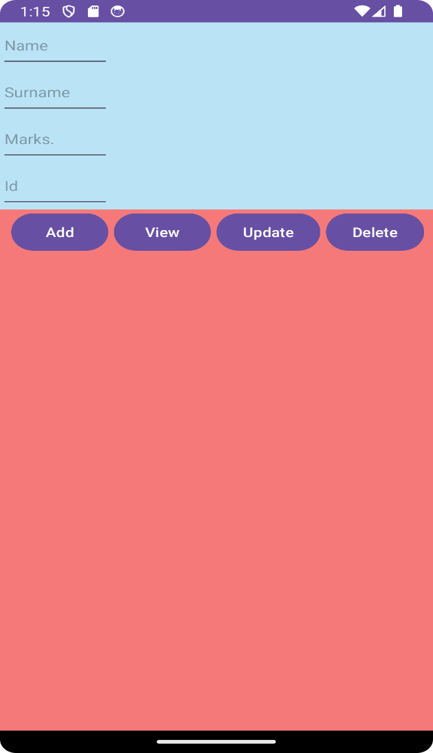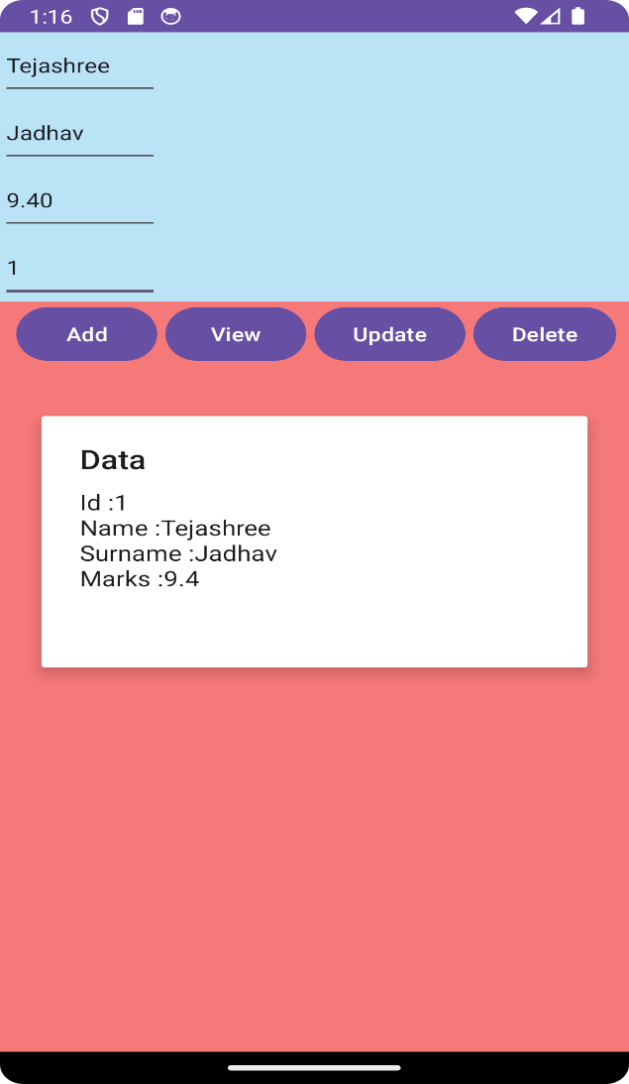

Kohak

Anket

Kohak

Anket

**PRACTICAL No.18**

**AIM: Create an Android Application to download an image using**

**HTTPURLConnection**

**CODE:**

**Activity_main.xml:**

*<?*xml version="1.0" encoding="utf-8"*?>*

<androidx.constraintlayout.widget.ConstraintLayout

xmlns:android="http://schemas.android.com/apk/res/android" xmlns:app="http://schemas.android.com/apk/res-auto"

xmlns:tools="http://schemas.android.com/tools"

android:layout_width="match_parent"

android:layout_height="match_parent"

tools:context=".MainActivity">

<TextView

android:layout_width="wrap_content"

android:layout_height="wrap_content"

android:text="Anket 84"

android:textSize="25sp" />

<TextView

android:id="@+id/textView"

android:layout_width="wrap_content"

android:layout_height="wrap_content"

android:layout_alignParentTop="true"

android:layout_centerHorizontal="true"

android:text="Web Page Image"

android:textSize="30sp"

android:textStyle="bold"

app:layout_constraintBottom_toBottomOf="parent"

app:layout_constraintEnd_toEndOf="parent"

app:layout_constraintStart_toStartOf="parent"

app:layout_constraintTop_toTopOf="parent"

app:layout_constraintVertical_bias="0.078" />

<ImageView

android:id="@+id/imageView"

android:layout_width="337dp"

android:layout_height="487dp"

android:layout_below="@+id/textView"

android:layout_centerHorizontal="true"

app:layout_constraintBottom_toBottomOf="parent"

app:layout_constraintEnd_toEndOf="parent"

app:layout_constraintStart_toStartOf="parent"

app:layout_constraintTop_toTopOf="parent" />

<Button

android:id="@+id/button"

android:layout_width="wrap_content"

android:layout_height="wrap_content"

android:layout_centerInParent="true"

android:text="Download"

android:textAppearance="@style/TextAppearance.AppCompat.Display1"

app:layout_constraintBottom_toBottomOf="parent"

app:layout_constraintEnd_toEndOf="parent"

app:layout_constraintStart_toStartOf="parent"

app:layout_constraintTop_toTopOf="parent"

app:layout_constraintVertical_bias="0.939" />

</androidx.constraintlayout.widget.ConstraintLayout>

**MainActivity.java**:

package com.example.myapplication11;

import androidx.appcompat.app.AppCompatActivity;

import android.annotation.SuppressLint;

import android.app.ProgressDialog;

import android.graphics.Bitmap;

import android.graphics.BitmapFactory;

import android.net.ConnectivityManager;

import android.os.Bundle;

import android.os.Handler;

import android.os.Message;

import android.view.View;

import android.widget.Button;

import android.widget.ImageView;

import android.widget.Toast;

import java.io.IOException;

import java.io.InputStream;

import java.net.HttpURLConnection;

import java.net.MalformedURLException;

import java.net.URL;

import java.net.URLConnection;

public class MainActivity extends AppCompatActivity

{

private ProgressDialog progressDialog;

private Bitmap bitmap = null;

Button b1;

@Override

protected void onCreate(Bundle savedInstanceState) {

super.onCreate(savedInstanceState);

setContentView(R.layout.*activity_main*);

b1 = (Button)findViewById(R.id.*button*);

b1.setOnClickListener(new View.OnClickListener() {

@Override

public void onClick(View v) {

checkInternetConenction();

downloadImage("https://lh3.googleusercontent.com/pw/ADCreHfyxK4eQokq0Hu8sOZ U2Bfb_9CH9583N1FkMvWBPwDGo6TgfjD2Zex-7nnyNsGD19mm2QiQVd1wUKSlxVBBgqnTIUCKXTOMCr

7mfrmWhSqDjSpNdoic- qp

mIBocA62iSj3boO1FwTxte1LNnf98AzC46eRv9cnI9aBLqNZIeqN1o_y99FcHkAT4nAMQfvQg9h WO9SLdx1RAmk4omono-BgLUmW2_bB3Y6UaPtoBbncnqLe315K-

_abgBxiXW99bIIJaYcD6DnUhIK6mfs5pbpbWklZKB7DSikA

bYGMWiKWNMVluS2NtV5DIrBM06HHrGMcP6R3hRR2HoRJz5FVIT5EV1ELMjUJV81WoAj8ZrRI5Kg L_y9HOYvJauyZY9sDZBRl_exScP4ecCggQBWK63a9QSQoTjpHgqHyDcqwswh7yPjK7pSvjyuxiC 89W2i89YRnuwi1Mv0hsL9k6Mw_lApwBh9yo3S41L

4Qg_2Gcuq3vtgPykBIcT6wWPsCgFzP0lVo37IVHD31yXuEgp46n0ReSsoEq7EAN4dN_JGWTTjrQ B2-9p2luoaq9A7co9TiHRIEqIsXXP8sNUFIQ7o7bUIzKhv_3ANCc6xy--

WvzbEUjamXEHz8vhKUl77u2Abk6YJTiLRceNetLuARldUHjBx5c33Ifci4rgi4f_sjXUlE5itOf WTe08Eb1tWqsQK8FTY7v1-56Y4Eg6_JAvfkBgSVyMSFvrWlZEVLz6aOCIJQRapCM fA0STOY4a_Y5qsT50O7IK5O9D_yYkzeTqjPJ3ARgKv3-

IxNzh55Hkx1myzUbcBE30Is0nki9rNzGSNplHv0UxJa9e-ytf

WguItgSXUgoXu5DQa3x2INDjl0_VlzrS0C-uKKqfzNx-J9yfguxZQGSbvnKvPvkcx1xiw=w727- h969-s-no-gm?authuser=2;");

}

});

}

private void downloadImage(String urlStr)

{

progressDialog = ProgressDialog.*show*(this, "", "Downloading Image from " +

urlStr);

final String url = urlStr;

new Thread() {

public void run()

{

InputStream in = null;

Message msg = Message.*obtain*();

msg.what = 1;

try

{

in = openHttpConnection(url);

bitmap = BitmapFactory.*decodeStream*(in);

Bundle b = new Bundle();

b.putParcelable("bitmap", bitmap);

msg.setData(b);

in.close();

}

catch (Exception e1 )

{

e1.printStackTrace();

}

messageHandler.sendMessage(msg);

}

}.start();

}

private InputStream openHttpConnection(String urlStr)

{

InputStream in = null;

int resCode = -1;

try {

URL url = new URL(urlStr);

URLConnection urlConn = url.openConnection();

if(!(urlConn instanceof HttpURLConnection))

{

throw new IOException("URL is not an Http URL");

}

HttpURLConnection httpConn = (HttpURLConnection) urlConn; httpConn.setAllowUserInteraction(false);

httpConn.setInstanceFollowRedirects(true);

httpConn.setRequestMethod("GET");

httpConn.connect();

resCode = httpConn.getResponseCode();

if (resCode == HttpURLConnection.*HTTP_OK*)

{

in = httpConn.getInputStream();

}

}

catch (MalformedURLException e)

{

e.printStackTrace();

}

catch (IOException e)

{

e.printStackTrace();

}

return in;

}

public Handler messageHandler = new Handler()

{

public void handleMessage(Message msg)

{

super.handleMessage(msg);

ImageView img=(ImageView)findViewById(R.id.*imageView*);

img.setImageBitmap((Bitmap)

(msg.getData().getParcelable("bitmap")));

progressDialog.dismiss();

}

};

private boolean checkInternetConenction() {

*// get Connectivity Manager object to check connection*

ConnectivityManager connec =

(ConnectivityManager)getSystemService(getBaseContext().*CONNECTIVITY_SERVICE* );

if (connec.getNetworkInfo(0).getState() ==

android.net.NetworkInfo.State.*CONNECTED* ||

connec.getNetworkInfo(0).getState() ==

android.net.NetworkInfo.State.*CONNECTING* ||

connec.getNetworkInfo(1).getState() ==

android.net.NetworkInfo.State.*CONNECTING* ||

connec.getNetworkInfo(1).getState()

==android.net.NetworkInfo.State.*CONNECTED* )

{

Toast.*makeText*(this, "Connected", Toast.*LENGTH_LONG*).show(); return true;

}

else if (connec.getNetworkInfo(0).getState() ==

android.net.NetworkInfo.State.*DISCONNECTED* ||

connec.getNetworkInfo(1).getState() ==

android.net.NetworkInfo.State.*DISCONNECTED* )

{

Toast.*makeText*(this,"Not Connected", Toast.*LENGTH_LONG*).show(); return false;

}

return false;

}

}

**AndroidManifest.xml**

*<?*xml version="1.0" encoding="utf-8"*?>*

<manifest xmlns:android="http://schemas.android.com/apk/res/android" package="com.example.myapplication11">

<uses-permission android:name="android.permission.INTERNET"/>

<uses-permission android:name="android.permission.ACCESS_NETWORK_STATE" /> <application

android:allowBackup="true"

android:icon="@mipmap/ic_launcher"

android:label="@string/app_name"

android:roundIcon="@mipmap/ic_launcher_round"

android:supportsRtl="true"

android:theme="@style/Theme.MyApplication11">

<activity

android:name=".MainActivity"

android:exported="true">

<intent-filter>

<action android:name="android.intent.action.MAIN" />

<category android:name="android.intent.category.LAUNCHER" />

</intent-filter>

</activity>

</application>

</manifest>

**OUTPUT:**

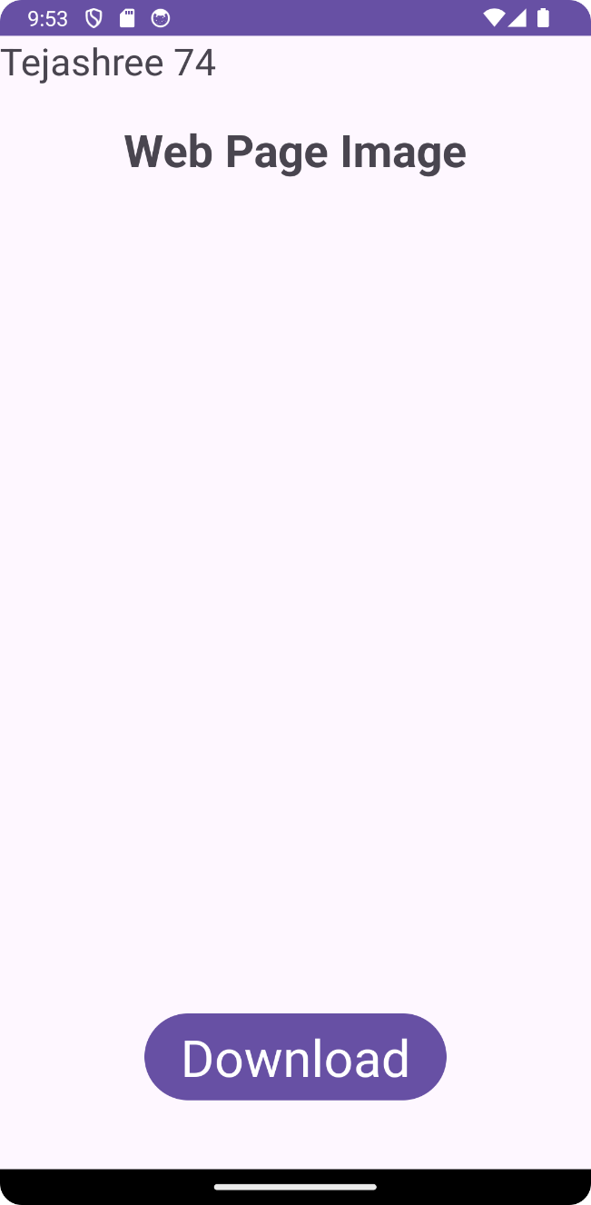 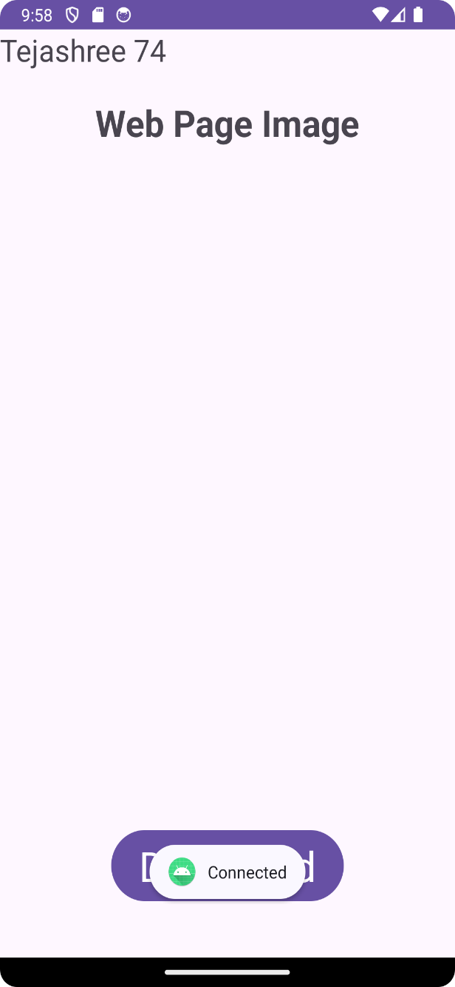

Anket 84

Anket 84

**PRACTICAL No.19**

**AIM: Create an Android Application to accept a user name and password and redirect to next page if it is right and 3 attempt only if it is wrong**

**CODE:**

**activity_main.xml**

***<?*xml version="1.0" encoding="utf-8"*?>***

**<RelativeLayout xmlns:android="http://schemas.android.com/apk/res/android"**

**xmlns:app="http://schemas.android.com/apk/res-auto"**

**xmlns:tools="http://schemas.android.com/tools"**

**android:layout_width="match_parent"**

**android:layout_height="match_parent"**

**tools:context=".MainActivity">**

**<EditText**

**android:id="@+id/et1"**

**android:layout_width="300dp"**

**android:layout_height="50dp"**

**android:layout_marginTop="120dp"**

**android:ems="10"**

**android:inputType="textPersonName"**

**android:textSize="25sp" />**

**<EditText**

**android:id="@+id/et2"**

**android:layout_width="300dp"**

**android:layout_height="50dp"**

**android:layout_below="@id/txt4"**

**android:ems="10"**

**android:inputType="textPassword"**

**android:textSize="25sp" />**

**<Button**

**android:id="@+id/button1"**

**android:layout_width="341dp"**

**android:layout_height="wrap_content"**

**android:layout_below="@id/et2"**

**android:layout_centerHorizontal="true"**

**android:layout_marginBottom="200dp"**

**android:text="Login"**

**android:textColor="#01090F"**

**android:textSize="36sp" />**

**<TextView**

**android:id="@+id/txt3"**

**android:layout_width="wrap_content"**

**android:layout_height="wrap_content"**

**android:layout_marginTop="85dp"**

**android:text="User Name"**

**android:textSize="25sp" />**

**<TextView**

**android:id="@+id/txt4"**

**android:layout_width="wrap_content"**

**android:layout_height="wrap_content"**

**android:layout_below="@id/et1"**

**android:text="Password"**

**android:textSize="25sp" />**

**</RelativeLayout>**

**MainActivity.java:**

**package** com.example.wrongattempts;

**import** androidx.appcompat.app.AlertDialog;

**import** androidx.appcompat.app.AppCompatActivity;

**import** android.content.DialogInterface;

**import** android.content.Intent;

**import** android.os.Bundle;

**import** android.view.View;

**import** android.widget.Button;

**import** android.widget.EditText;

**public class** MainActivity **extends** AppCompatActivity {

Button **button1**;

EditText **et1**, **et2**;

String **username**, **password**;

**int attempt_counter**;

@Override

**protected void** onCreate(Bundle savedInstanceState) {

**super**.onCreate(savedInstanceState);

setContentView(R.layout.*activity_main*);

**button1** = (Button) findViewById(R.id.*button1*);

**et1** = (EditText) findViewById(R.id.*et1*);

**et2** = (EditText) findViewById(R.id.*et2*);

**button1**.setOnClickListener(**new** View.OnClickListener() {

@Override

**public void** onClick(View view) {

**username** = **et1**.getText().toString();

**password** = **et2**.getText().toString();

**if** (**username**.equals(**"Anket"**) &**password**.equals(**"1234"**)) {

Intent intent = **new** Intent(MainActivity.**this**,

welcome.**class**);

String message = **et1**.getText().toString();

intent.putExtra(**"hello"**, message);

startActivity(intent);

} **else** {

**attempt_counter**++;

**if** (**attempt_counter** == 3) {

**button1**.setEnabled(**false**);

AlertDialog.Builder a_builder = **new**

AlertDialog.Builder(MainActivity.**this**);

a_builder.setMessage(**"3 attempt made"**)

.setCancelable(**false**)

.setNegativeButton(**"OK"**, **new** DialogInterface.OnClickListener() {

@Override

**public void** onClick(DialogInterface dialog, **int** i) {

dialog.cancel();

}

});

AlertDialog alert = a_builder.create();

alert.setTitle(**"Retry!!"**);

alert.show();

}

AlertDialog.Builder a_builder = **new**

AlertDialog.Builder(MainActivity.**this**);

a_builder.setMessage(**"Incorrect username or password "**

+ **attempt_counter** + **" attempts made"**)

.setCancelable(**false**)

.setNegativeButton(**"OK"**, **new** DialogInterface.OnClickListener() {

**public void** onClick(DialogInterface dialog, **int** which) {

dialog.cancel();

}

});

AlertDialog alert = a_builder.create();

alert.setTitle(**"Alert!!"**);

alert.show();

}

}

});

}

}

**activity_welcome.xml**

*<?***xml version="1.0" encoding="utf-8"***?>*

<**RelativeLayout xmlns:android="http://schemas.android.com/apk/res/android"**

**xmlns:app="http://schemas.android.com/apk/res-auto"**

**xmlns:tools="http://schemas.android.com/tools"**

**android:layout_width="match_parent"**

**android:layout_height="match_parent"**

**tools:context=".welcome"**>

<**TextView**

**android:id="@+id/textView"**

**android:layout_width="364dp"**

**android:layout_height="70dp"**

**android:layout_alignParentStart="true"**

**android:layout_alignParentLeft="true"**

**android:layout_alignParentTop="true"**

**android:layout_marginStart="29dp"**

**android:layout_marginLeft="29dp"**

**android:layout_marginTop="264dp"**

**android:textSize="30dp"** />

</**RelativeLayout**>

**welcome.java**

**package** com.example.wrongattempts;

**import** androidx.appcompat.app.AppCompatActivity;

**import** android.content.Intent;

**import** android.os.Bundle;

**import** android.widget.TextView;

**public class** welcome **extends** AppCompatActivity {

TextView **textView**;

@Override

**protected void** onCreate(Bundle savedInstanceState) {

**super**.onCreate(savedInstanceState);

setContentView(R.layout.*activity_welcome*);

Intent intent = getIntent();

String message = intent.getStringExtra(**"hello"**);

**textView** = findViewById(R.id.*textView*);

**textView**.setText(**"Welcome "** + message);

}

}

**OUTPUT:**

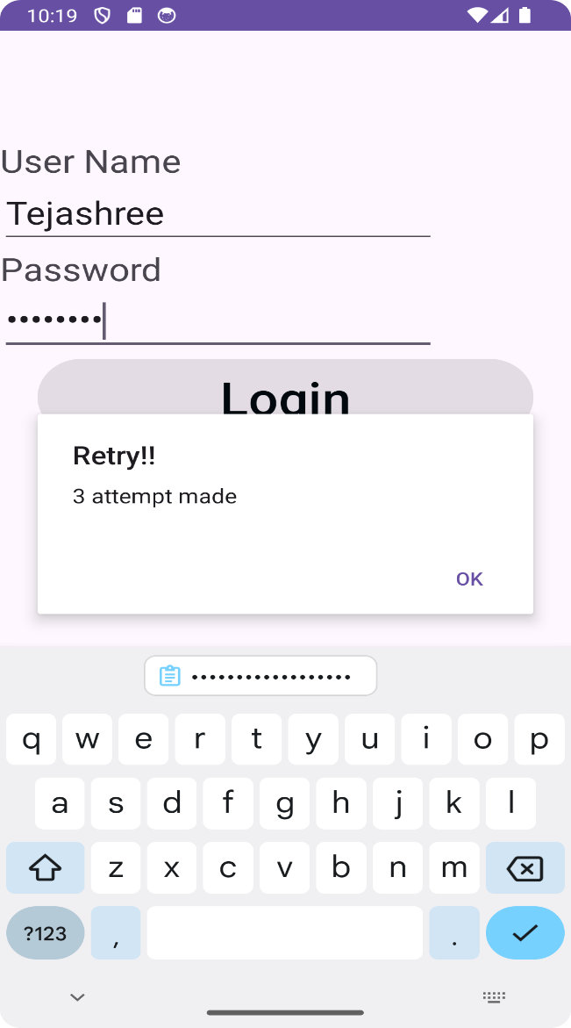

Anket

**PRACTICAL No.20**

**AIM: Create an Android Application to read and display JSON data**

**CODE:**

**activity_main.xml**

*<?*xml version="1.0" encoding="utf-8"*?>*

<RelativeLayout xmlns:android="http://schemas.android.com/apk/res/android"

xmlns:app="http://schemas.android.com/apk/res-auto"

xmlns:tools="http://schemas.android.com/tools"

android:layout_width="match_parent"

android:layout_height="match_parent"

tools:context=".MainActivity">

<TextView

android:id="@+id/tv1"

android:layout_width="match_parent"

android:layout_height="wrap_content"

android:gravity="center_horizontal"

android:text="SaaP Group"

android:textAlignment="center"

android:textColor="@android:color/holo_blue_light"

android:textSize="25sp" />

<TextView

android:id="@+id/text_view_result"

android:layout_width="wrap_content"

android:layout_height="wrap_content"

android:layout_below="@+id/tv1"

android:textColor="@android:color/holo_blue_light"

android:textSize="20sp" />

<Button

android:id="@+id/button_parse"

android:layout_width="wrap_content"

android:layout_height="wrap_content"

android:layout_alignParentBottom="true"

android:layout_centerHorizontal="true"

android:layout_marginBottom="30dp"

android:text="Parse" />

</RelativeLayout>

**MainActivity.java:**

package com.example.json;

import android.os.Bundle;

import android.view.View;

import android.widget.Button;

import android.widget.TextView;

import androidx.appcompat.app.AppCompatActivity;

import com.android.volley.Request;

import com.android.volley.RequestQueue;

import com.android.volley.Response;

import com.android.volley.VolleyError;

import com.android.volley.toolbox.JsonObjectRequest;

import com.android.volley.toolbox.Volley;

import org.json.JSONArray;

import org.json.JSONException;

import org.json.JSONObject;

public class MainActivity extends AppCompatActivity {

private TextView mText;

private RequestQueue mQueue;

@Override

protected void onCreate(Bundle savedInstanceState) {

super.onCreate(savedInstanceState);

setContentView(R.layout.*activity_main*);

mText = findViewById(R.id.*text_view_result*);

Button buttonParse = findViewById(R.id.*button_parse*);

mQueue = Volley.*newRequestQueue*(this);

buttonParse.setOnClickListener(new View.OnClickListener() {

@Override

public void onClick(View view) {

jsonParse();

}

});

}

private void jsonParse() {

String url = "https://api.npoint.io/5dfba5bca6ed3c48c80a";

JsonObjectRequest request = new JsonObjectRequest(

Request.Method.*GET*, url, null,

new Response.Listener<JSONObject>() {

@Override

public void onResponse(JSONObject response) {

try {

JSONArray jsonArray = response.getJSONArray("cars");

for (int i = 0; i < jsonArray.length(); i++) {

JSONObject cars = jsonArray.getJSONObject(i);

String color = cars.getString("color");

String brand = cars.getString("brand");

mText.append(color + ", " +brand + "\n\n");

}

} catch (JSONException e) {

e.printStackTrace();

}

}

},

new Response.ErrorListener() {

@Override

public void onErrorResponse(VolleyError error) {

error.printStackTrace();

}

}

);

mQueue.add(request);

}

}

**Build.gradel(app)**

plugins **{**

alias(*libs*.*plugins*.*android*.*application*)

**}**

*android* **{**

namespace = "com.example.json"

compileSdk = 34

defaultConfig **{**

applicationId = "com.example.json"

minSdk = 34

targetSdk = 34

versionCode = 1

versionName = "1.0"

testInstrumentationRunner = "androidx.test.runner.AndroidJUnitRunner"

**}**

buildTypes **{**

*release* **{**

isMinifyEnabled = false

proguardFiles(

getDefaultProguardFile("proguard-android-optimize.txt"),

"proguard-rules.pro"

)

**}**

**}**

compileOptions **{**

sourceCompatibility = JavaVersion.*VERSION_1_8*

targetCompatibility = JavaVersion.*VERSION_1_8*

**}**

**}**

*dependencies* **{**

*implementation*(*libs*.*appcompat*)

*implementation*(*libs*.*material*)

*implementation*(*libs*.*activity*)

*implementation*(*libs*.*constraintlayout*)

*implementation*("com.android.volley:volley:1.2.1")

*testImplementation*(*libs*.*junit*)

*androidTestImplementation*(*libs*.*ext*.*junit*)

*androidTestImplementation*(*libs*.*espresso*.*core*)

**}**

**AndroidManifest.xml**

*<?*xml version="1.0" encoding="utf-8"*?>*

<manifest xmlns:android="http://schemas.android.com/apk/res/android"

xmlns:tools="http://schemas.android.com/tools">

<application

android:allowBackup="true"

android:dataExtractionRules="@xml/data_extraction_rules"

android:fullBackupContent="@xml/backup_rules"

android:icon="@mipmap/ic_launcher"

android:label="@string/app_name"

android:roundIcon="@mipmap/ic_launcher_round"

android:supportsRtl="true"

android:theme="@style/Theme.Json"

tools:targetApi="31">

<activity

android:name=".MainActivity"

android:exported="true">

<intent-filter>

<action android:name="android.intent.action.MAIN" />

<category android:name="android.intent.category.LAUNCHER" />

</intent-filter>

</activity>

</application>

<uses-permission android:name="android.permission.INTERNET"/>

</manifest>

**OUTPUT:**

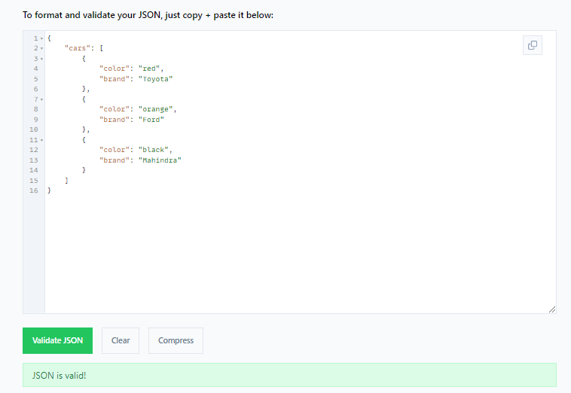

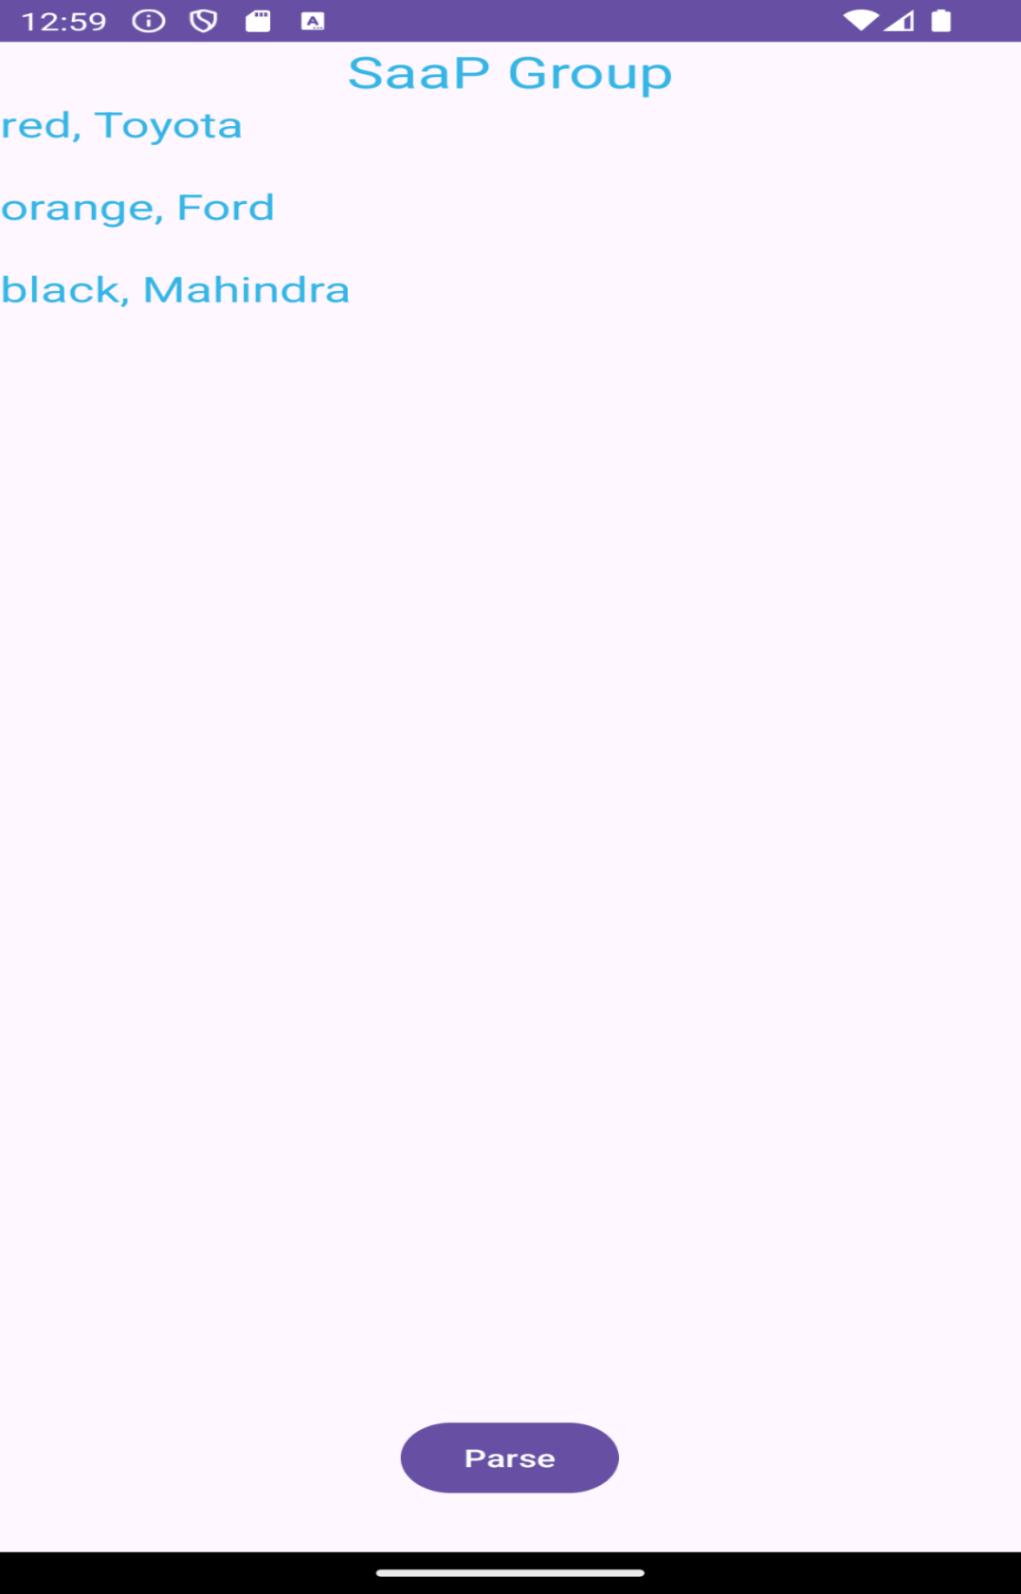

**PRACTICAL N0.21**

**AIM: Create a Flutter Application to display the message.**

**CODE:**

import 'package:flutter/material.dart';  
  
void main() {  
 runApp(const MyApp()); }  
class MyApp extends StatelessWidget {  
 const MyApp({super.key});  
 @override Widget build(BuildContext context) {  
 return MaterialApp( title: 'Flutter Demo',  
 theme: ThemeData( colorScheme: ColorScheme.fromSeed(seedColor: Colors.*deepPurple*), useMaterial3: true, ), home: const MyHomePage(title: 'Flutter Demo Home Page'), );  
} }  
class MyHomePage extends StatelessWidget {  
 const MyHomePage({super.key, required this.title});  
 final String title;  
@override  
Widget build(BuildContext context) {  
 return Scaffold(  
 appBar: AppBar( backgroundColor: Theme.*of*(context).colorScheme.inversePrimary, title: Text(title), ), body: Center( child: Column( mainAxisAlignment: MainAxisAlignment.center, children: const <Widget>[ Text( 'Hello, Flutter! Anket Kohak 84', style: TextStyle(fontSize: 24),  
),  
],  
),  
),  
);  
}  
}

**OUTPUT:**

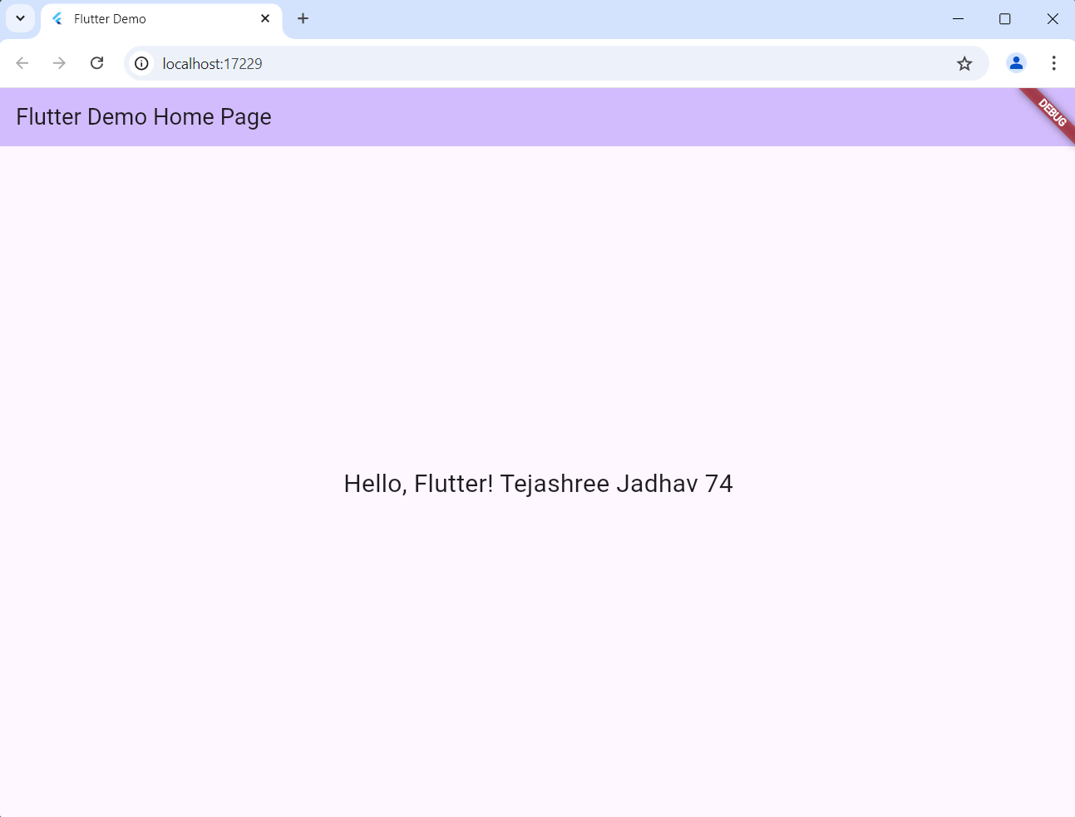

Anket 84

**PRACTICAL No.22**

**AIM: Create a Flutter Application to display the Raised Button**

**CODE:**

import 'package:flutter/material.dart';  
  
void main() {  
 runApp(const MyApp());  
}  
class MyApp extends StatelessWidget {  
 const MyApp({Key? key}) : super(key: key);  
 @override  
 Widget build(BuildContext context) {  
 return MaterialApp(  
 debugShowCheckedModeBanner: false,  
 home: Scaffold(  
 appBar: AppBar(  
 title: Text('MOBILE COMPUTING FLUTTER Anket 84'),  
 ),  
 body: Center(  
 child: ElevatedButton(  
 onPressed: () {},  
 child: Text("Raised Button", style: TextStyle(fontSize: 20.0)),  
 )),  
 ));  
 }  
}

**OUTPUT:**

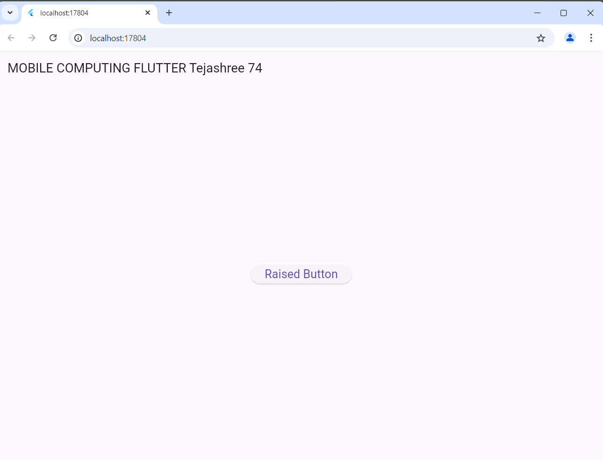

Anket 84

**PRACTICAL No.23**

**AIM: Create a Flutter Application to display an image.**

**CODE:**

import 'package:flutter/material.dart';

void main() {

 runApp(MaterialApp(

   home: Scaffold(

     body: Center(

         child: Image.network('https://png.pngtree.com/thumb_back/fw800/background/20240601/pngtree-picsart-editing-background-with-nature-and-tree-google-vignette-photos-image_15846438.jpg')

     ),

   ),

 ));

}

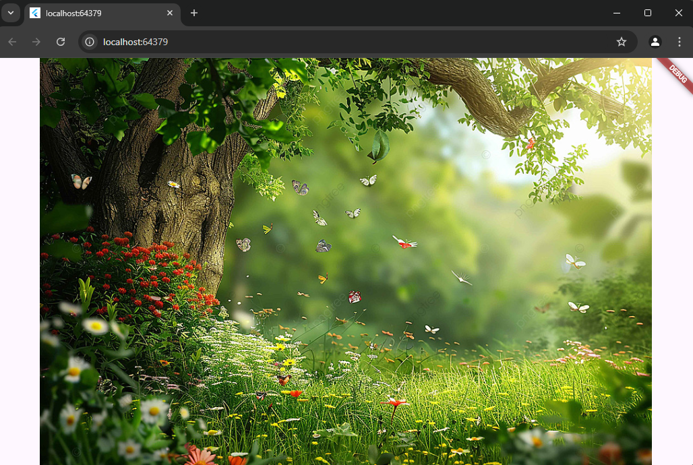

**PRACTICAL No.24**

**AIM: Create a Flutter Application to display the message how many times the button has been clicked.**

**CODE:**

import 'package:flutter/material.dart';  
void main() { runApp(const MyApp()); }  
class MyApp extends StatelessWidget { const MyApp({super.key});  
@override Widget build(BuildContext context) { return MaterialApp( title: 'Flutter', theme: ThemeData( colorScheme: ColorScheme.fromSeed(seedColor: Colors.*deepPurple*), useMaterial3: true, ), home: const MyHomePage(title: 'Flutter'), );  
} }  
class MyHomePage extends StatefulWidget { const MyHomePage({super.key, required this.title}); final String title;  
@override  
_MyHomePageState createState() => _MyHomePageState(); }  
class _MyHomePageState extends State<MyHomePage> { int _counter = 0;  
void _incrementCounter() { setState(() { _counter++;  
});  
}  
@override Widget build(BuildContext context) { return Scaffold( appBar: AppBar( backgroundColor: Theme.*of*(context).colorScheme.inversePrimary, title: Text(widget.title), ), body: Center( child: Column( mainAxisAlignment: MainAxisAlignment.center, children: <Widget>[ const Text( 'Hello, Flutter! Anket Kohak 84', style: TextStyle(fontSize: 24), ),  
 const SizedBox(height: 20), Text( 'Button pressed $_counter times', style: Theme.*of*(context).textTheme.headlineMedium, ),  
 const SizedBox(height: 20), ElevatedButton( onPressed: _incrementCounter, child: const Text('Press Me'), ),  
],  
),  
),  
);  
}  
}

**OUTPUT:**

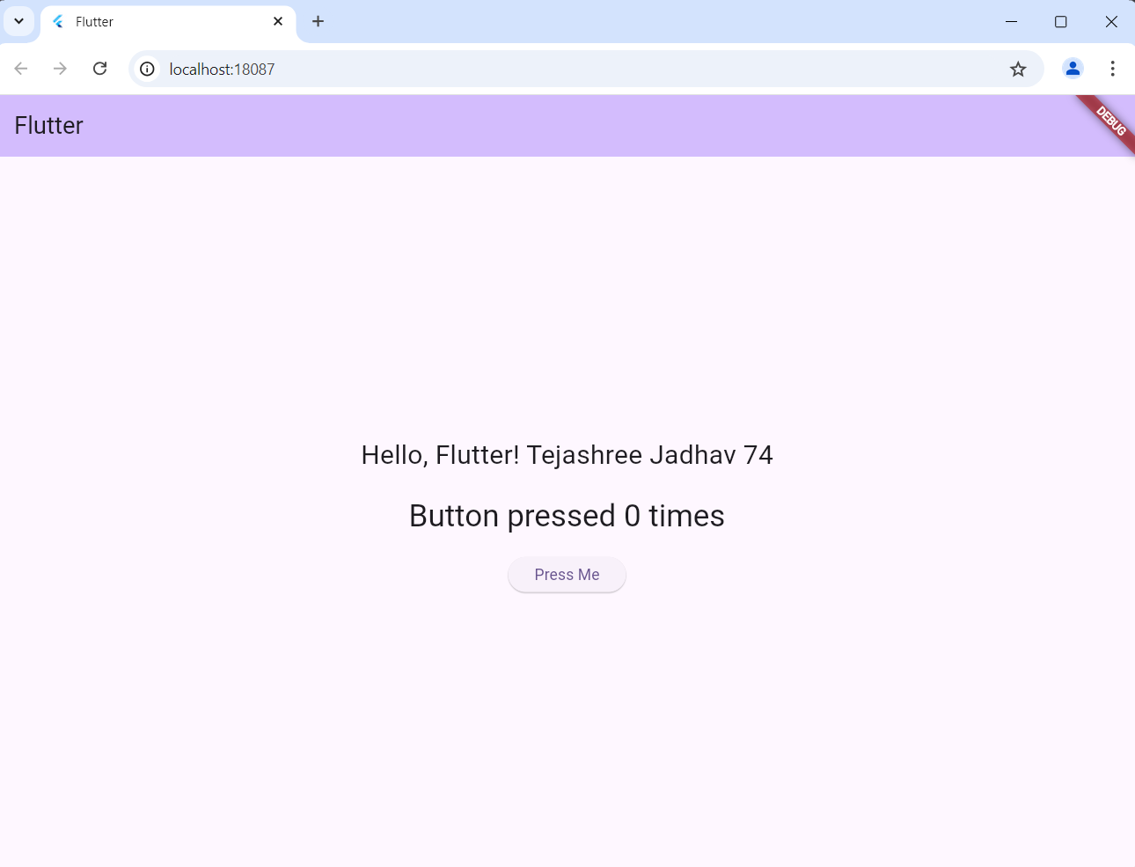

Anket Kohak84

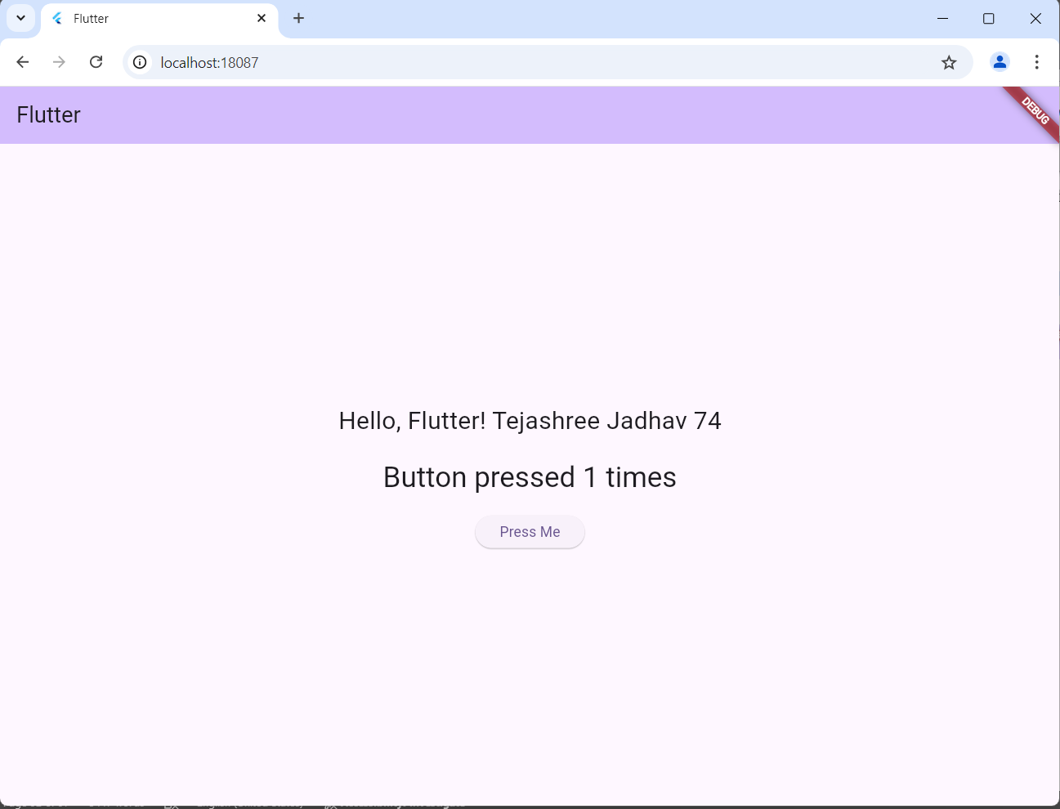

Anket Kohak 84

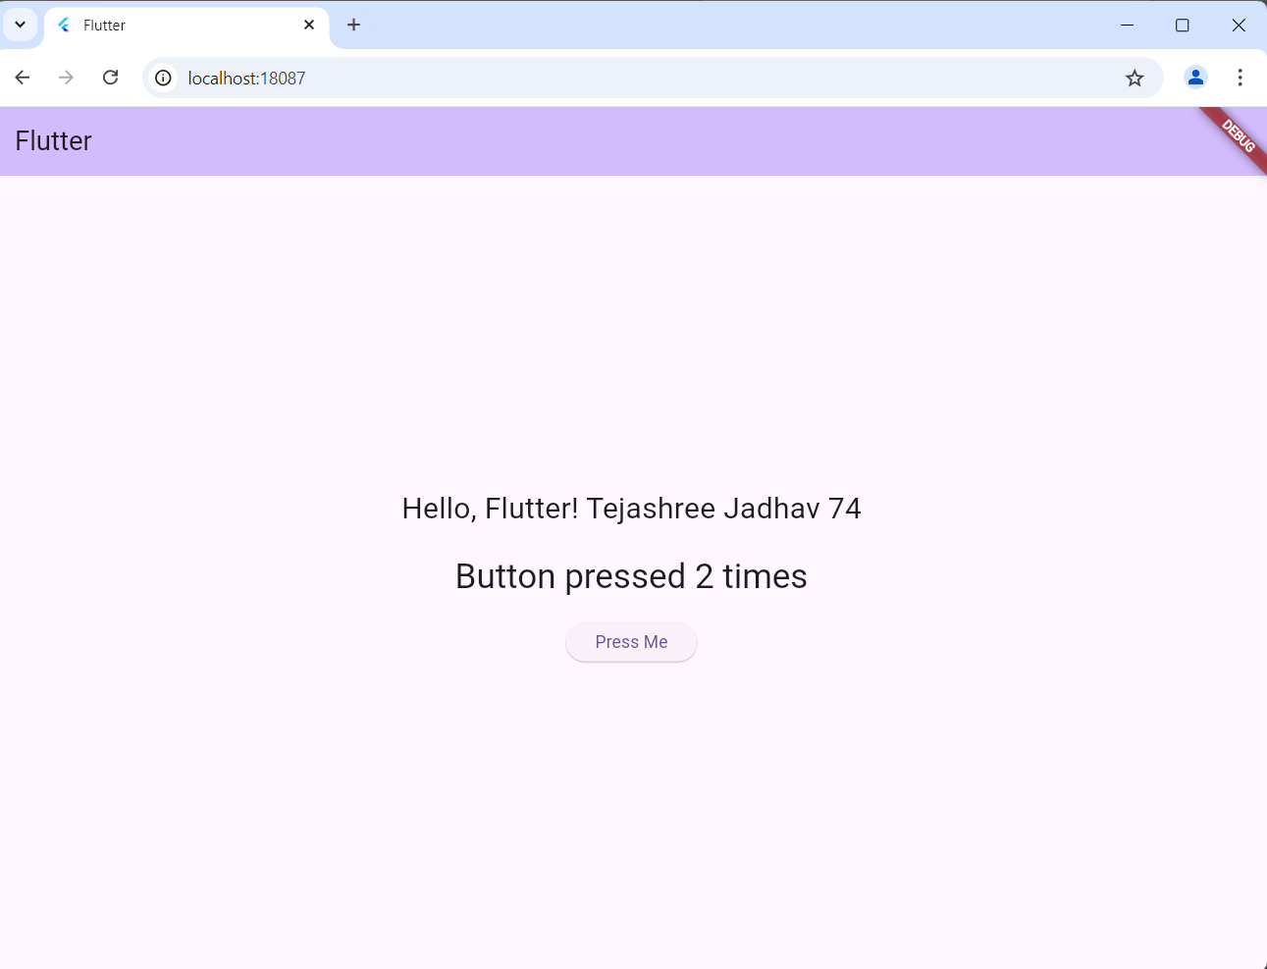

Anket Kohak 84

**PRACTICAL No.25**

**AIM**: **Create a Flutter Application to display a form**

**CODE:**

import 'package:flutter/material.dart';  
  
void main() => runApp(MyApp());  
  
class MyApp extends StatelessWidget {  
 @override  
 Widget build(BuildContext context) {  
 return MaterialApp(  
 debugShowCheckedModeBanner: false,  
 theme: ThemeData(  
 primarySwatch: Colors.*green*, *// Set the app's primary theme color* ),  
 title: 'Flutter Form Example',  
 home: MyForm(),  
 );  
 }  
}  
  
class MyForm extends StatefulWidget {  
 @override  
 _MyFormState createState() => _MyFormState();  
}  
  
class _MyFormState extends State<MyForm> {  
 final GlobalKey<FormState> _formKey = GlobalKey<FormState>(); *// A key for managing the form* String _name = ''; *// Variable to store the entered name* String _email = ''; *// Variable to store the entered email* void _submitForm() {  
 *// Check if the form is valid* if (_formKey.currentState!.validate()) {  
 _formKey.currentState!.save(); *// Save the form data  
 // You can perform actions with the form data here and extract the details* print('Name: $_name'); *// Print the name* print('Email: $_email'); *// Print the email* }  
 }  
  
 @override  
 Widget build(BuildContext context) {  
 return Scaffold(  
 appBar: AppBar(  
 title: Text('Flutter Form Example'),  
 ),

body: Form(  
 key: _formKey, *// Associate the form key with this Form widget* child: Padding(  
 padding: EdgeInsets.all(16.0),  
 child: Column(  
 children: <Widget>[  
 TextFormField(  
 decoration: InputDecoration(labelText: 'Name'), *// Label for the name field* validator: (value) {  
 *// Validation function for the name field* if (value!.isEmpty) {  
 return 'Please enter your name.'; *// Return an error message if the name is empty* }  
 return null; *// Return null if the name is valid* },  
 onSaved: (value) {  
 _name = value!; *// Save the entered name* },  
 ),  
 TextFormField(  
 decoration: InputDecoration(labelText: 'Email'), *// Label for the email field* validator: (value) {  
 *// Validation function for the email field* if (value!.isEmpty) {  
 return 'Please enter your email.'; *// Return an error message if the email is empty* }  
 *// You can add more complex validation logic here* return null; *// Return null if the email is valid* },  
 onSaved: (value) {  
 _email = value!; *// Save the entered email* },  
 ),  
 SizedBox(height: 20.0),  
 ElevatedButton(  
 onPressed: _submitForm, *// Call the _submitForm function when the button is pressed* child: Text('Submit'), *// Text on the button* ),  
 ],  
 ),  
 ),  
 ),  
 );  
 }  
}

**OUTPUT:**

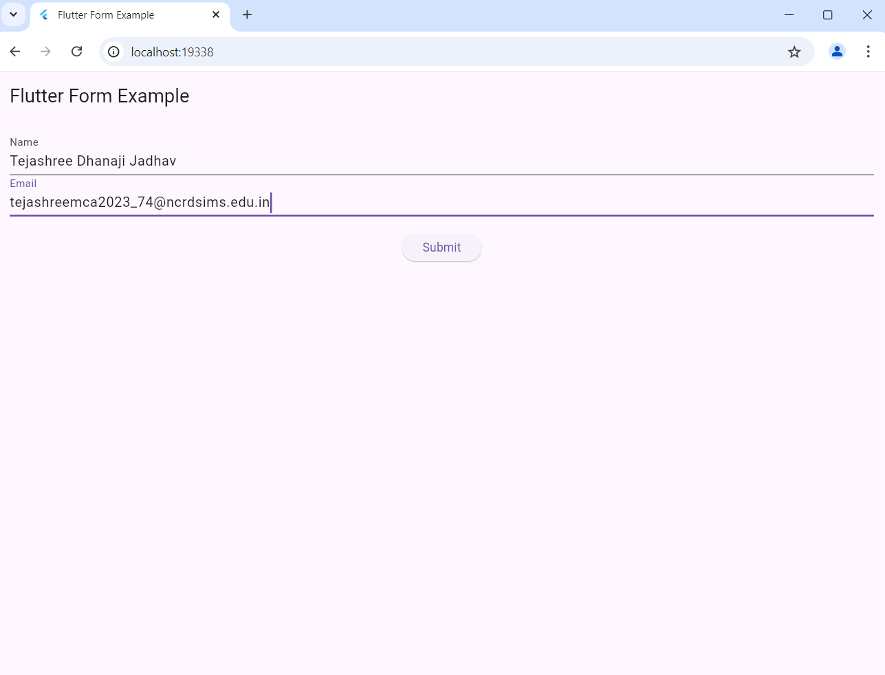

[Anketkohak40@gmail.com](mailto:Anketkohak40@gmail.com)

Anket kanifanth 84